**ONLINE RECEIPT UPLOADER FOR**

**PHINMA UNIVERSITY OF PANGASINAN**

A Capstone Project Presented to the

Faculty of the

College of Information Technology and Education

PHINMA-University of Pangasinan

In Fulfillment

of the Requirements for the Degree

BACHELOR OF SCIENCE IN INFORMATION TECHNOLOGY

By

DE GUZMAN, JANINE C.

DELO SANTOS, KIM CHARLIE L.

CRUZ, JULIAN GABRIEL G.

QUISAO, JOSHUA Z.

BARROZO, VICKY A.

AQUINO, ERICK JOHN

May 2022**APPROVAL SHEET**

This project study entitled ONLINE RECEIPT FOR PHINMA UNIVERSITY OF PANGASINAN prepared and submitted by JULIAN GABRIEL S. CRUZ, KIM CHARLIE L. DELO SANTOS, JOSHUA Z. QUISAO, JANINE C. DE GUZMAN, VICKY A. BARROZO, ERICK JOHN AQUINO in partial fulfillment of the requirements for the degree BACHELOR OF SCIENCE IN INFORMATION TECHNOLOGY, has been examined and is recommended for acceptance and approval for oral examination.

ANGELICA F. VIDAL

Adviser

Project Study Committee

PANEL MEMBER (CAPS), Degree PANEL MEMBER (CAPS), Degree

Member Member

NAME OF CHAIRPERSON(CAPS), Degree

Chairperson

PANEL OF EXAMINERS

APPROVED by the Committee on Oral Examination on

__________________ with a grade of _________.

NAME OF CHAIRPERSON(CAPS), Degree

Chairperson

PANEL MEMBER (CAPS), Degree PANEL MEMBER (CAPS), Degree

Member Member

ACCEPTED AND APPROVED in partial fulfillment of the requirements for the degree BACHELOR OF SCIENCE IN INFORMATION TECHNOLOGY.

ARISTOTLE B. LIWANAG, MBA

Dean

College of Information Technology Education

**PROJECT STUDY ABSTRACT**

1. Title: **ONLINE RECEIPT UPLOADER FOR PHINMA UNIVERSITY OF PANGASINAN**

* 1. Total No of page: ___
  2. Text No of page: ___

2. Author: **DE GUZMAN, JANINE C.**

**DELOS SANTOS, KIM CHARLIE L.**

**CRUZ, JULIAN GABRIEL G.**

**QUISAO, JOSHUA Z.**

**BARROZO, VICKY A.**

**AQUINO ERICK JOHN A.**

3. Type of Document: Project Study

4. Keywords: Receipt, Security, Cashless Payment, Digital Payment, Financial Transaction, Proof of Payment, Tuition Fee, Website, Finance Department, Verification.

5. Abstracts:

5.1 **Background of the Study**

Technology has been one of the most important things in the modern world and its effect on society is getting deeper and more complex. It is significant that it has a big impact on every aspect of society and has also managed to improve efficiency and effectiveness. Someone cannot refute the fact that technology has contributed to transforming their lives and changing things for the better. Indeed, the incorporation of technological advances into various aspects of their lives has helped change the environment and increase productivity in everything they do. Technology comes in various forms, and nowadays people offer different interpretations of it, and most of them rely on whether or how it has been useful in one's work. The role and impact of technology in both personal and working lives are ever-growing.

5.2 **Summary**

This study aims to create an Online Receipt Uploader for Phinma-University of Pangasinan to provide an easy and friendly system for the students of Phinma-Upang.

5.3 **Findings**

This chapter tackled the dilemmas and interpretation of the findings resulting from this study. The designs and features of the proposed project will be discussed.

5.4 **Conclusions**

The purpose of this research is to help the Students of Phinma-Upang to facilitate their submission of the proof of payment Online. It will enable the students to submit their receipts easily and, they are also allowed to choose what kind of paying the tuition fee they want, and to maintain their safety.

5.5 **Recommendations**

Based on the above findings and conclusions of the study, it is highly recommended that the Online Receipt Uploader for Phinma-university of Pangasinan to be implemented

1. In the near future, the system will include the distribution of permits.

2. It is necessary to arrange the upkeep of the proposed Online Receipt Uploader with the Department of Information Technology Systems and/or the Information Technology College Education.

3. An evaluation of the proposed system is required frequently.

**ACKNOWLEDGEMENT**

Thanks to Almighty God for giving the researchers the strength and ability to understand, learn and complete this study.

We would like to admire the help and guidance of Professor Angelica Fernandez Vidal. Her full support, guidance, and encouragement throughout our study and research made us motivated. Without her incredible patience, timely wisdom, and council, our research study would have been a frustrating and overwhelming pursuit. In addition, We would like to express our appreciation to our fellow researchers who helped us with our course work and academic research. We would also like to thank the students who were involved in the Validation survey of this Research Project. Without their passionate participation and input, the validation of the survey could not have been successfully conducted.

Thank you also to the fellow CITE students of Phinma University of Pangasinan, Dagupan Campus.

**DEDICATION**

This is the fruit of countless and difficult sacrifices. Through the researchers effort, this is heartily and proudly dedicated to the people who serve as an inspiration. From our professors, and parents, to classmates and circle of friends who extended their help in the midst of problems while doing this work.

To the faculty and staff of the College of Information and Technology Education, thank you. Above all, to our God who guides us in our everyday lives, especially for the strength, courage, patience, wisdom, time, and guidance in realization of this work.

The Researchers

**TABLE OF CONTENTS**

Page

TITLE PAGE . . . . . . . . . . . . . . . . . . . . . . 1

APPROVAL SHEET . . . . . . . . . . . . . . . . . . . . 2

PROJECT STUDY ABSTRACT . . . . . . . . . . . . . . . . 3

ACKNOWLEDGEMENT . . . . . . . . . . . . . . . . . . . . 6

DEDICATION. . . . . . . . . . . . . . . . . . . . . . . 7

TABLE OF CONTENTS . . . . . . . . . . . . . . . . . . . 8

LIST OF FIGURES . . . . . . . . . . . . . . . . . . . . 10  
LIST OF TABLES . . . . . . . . . . . . . . . . . . . . . 11

CHAPTER

1 PROJECT OVERVIEW

Background of the Study . . . . . . . . . . . 12  
 Review of Literature. . . . . . . . . . . . . 16  
 Importance of the Study . . . . . . . . . . . 27

Statement of the Problem. . . . . . . . . . . 29

Objectives of the Study . . . . . . . . . . . 30

Definition of Terms . . . . . . . . . . . . . 30

2 METHODOLOGY

Software Development Methodology. . . . . . . 33

Scope and Delimitation. . . . . . . . . . . . 37

Data Gathering Techniques . . . . . . . . . . 38

Sources of Data . . . . . . . . . . . . . . . 39

3 DISCUSSION OF FINDINGS

Answer for SOP #1 . . . . . . . . . . . . . . 41

Answer for SOP #2 . . . . . . . . . . . . . . 44

Answer for SOP #3 . . . . . . . . . . . . . . 57

System Design . . . . . . . . . . . . . . . . 69

4 CONCLUSIONS AND RECOMMENDATIONS

Conclusions . . . . . . . . . . . . . . . . . 76

Recommendations . . . . . . . . . . . . . . . 77

REFERENCES. . . . . . . . . . . . . . . . . . . . . . . 78

APPENDICES

A Survey Questionnaire . . . . . . . . . . . . . 79

B Post-test Questionnaire . . . . . . . . . . . 84

CURRICULUM VITAE. . . . . . . . . . . . . . . . . . . . 87

**LIST OF FIGURES**

Figure No. Title Page

1 Uploading of Receipts in Uploader Module . . . 45

2 List of the Students on the admin account. . . 46

3 Request record in the Admin Account . . . . . .47  
 4 Report on Student Records. . . . . . . . . . . 48

5 Payment History for Student Account. . . . . . 49  
 6 Login for student Account. . . . . . . . . . . 50  
 7 Student Dashboard. . . . . . . . . . . . . . . 52

8 Student Profile. . . . . . . . . . . . . . . . 53

9 Admin Login. . . . . . . . . . . . . . . . . . 53

10 Admin Dashboard. . . . . . . . . . . . . . . . 54

11 Admin Profile. . . . . . . . . . . . . . . . . 54

12 Admin User Account . . . . . . . . . . . . . . 55

13 Admin User Logs. . . . . . . . . . . . . . . . 55

14 Settings . . . . . . . . . . . . . . . . . . . 56

15 Secretary Login . . . . . . . .. . . . . . . 57

16 Student Permit Record . . . . . . . . . . . . 57

17 Weighted mean for Usefulness . . . . . . . . . 61  
 18 Weighted mean for Ease of Use. . . . . . . . . 63  
 19 Weighted mean for Ease of Learning . . . . . . 65  
 20 Weighted mean for Satisfaction . . . . . . . . 67  
 21 Systems Architecture . . . . . . . . . . . . . 72

**LIST OF TABLES**

Table No. Title Page

1 Table of Level of Acceptability for Usefulness. . . . 59

2 Table of Level of Acceptability for Ease of Use . . . 62

3 Table of Level of Acceptability for Ease of Learning. 64  
4 Table of Acceptability of Satisfaction. . . . . . . . 66  
5 Likert-type Scale Definition for Level of Acceptability . . . . . . . . . . . . . . . . . . . . . . . . . . . . 68  
6 Summary of Weighted Mean . . . . . . . . . . . . . . . 69  
7 Software Requirements . . . . . . . . . . . . . . . . 73  
8 Hardware Requirements. . . . . . . . . . . . . . . . . 74

Chapter 1

**PROJECT OVERVIEW**

# **Background of the Study**

Technology has been one of the most important things in the modern world and its effect on society is getting deeper and more complex. It is significant that it has a big impact on every aspect of society and has also managed to improve efficiency and effectiveness. Someone cannot refute the fact that technology has contributed to transforming their lives and changing things for the better. Indeed, the incorporation of technological advances into various aspects of their lives has helped change the environment and increase productivity in everything they do. Technology comes in various forms, and nowadays people offer different interpretations of it, and most of them rely on whether or how it has been useful in one's work.

The role and impact of technology in both personal and working lives are ever-growing. Understanding how people shape technology and how technology shapes people's interactions with each other and the natural world is important not only for those who research, develop and implement new technologies but also for all those people and organizations that have to use those technologies in their working and personal lives.

The progression of information technology in the 21st century has made countless lives more convenient. The world became even more interconnected, and it has become a tool for every individual. This technology is constantly changing, and as it is advancing, more uses of it are being implemented. The ability to make a payment is a critical factor enabling trade in the modern economy. Payment systems have evolved over time to respond to people’s desire to transact in large columns, with greater efficiency, and across national borders; whilst the online payments industry emerged in order to provide more efficient banking solutions and unlock the potential for internet-based trade. A student tuition fee payment receipt includes a number of significant details as it has to accurately identify the student with the payment record.

A tuition fee receipt is a formal document stating the fee paid in terms of educational expenses of a student, given as proof to the guardian or parents of the student. Any educational organization involved in the provision of education at various levels issues a tuition fee receipt to the students or their guardians a tangible proof of the transactions involved between the two parties for the payment of the educational services provided. Sometimes the tuition fee is not fully paid or paid in installments still the tuition fee receipt is issued with a balanced amount mentioned along. A student tuition fee payment receipt includes a number of significant details as it has to accurately identify the student with the payment record. The components of a tuition fee payment receipt are as follows:

* **Organizational Details:** The name and type of the educational organization whether a school, college, or university along with its address should be mentioned in the header with its logo.
* **Student’s Identification:** The name of the student along with his/her guardian or parents' name and the student’s identification number within the organization is stated. Moreover, the department and grade/year of the student in which he/she is reading is also mentioned. If the format of the organization requires then other necessary information of the students can also be mentioned.
* **Date:** The date of the issuance of receipt is mentioned and is very important to be accurate since that is a proof that the payment was done within the due or if after the due then how long has it been overdue.
* **Billing Details:** This section is the sole purpose of the receipt. It provides information about the various components of the tuition fee being taken i.e. the laboratory charges, library charges, tuition fee, etc. Since, some organizations provide the student with adequate uniforms and stationery as well, along with the tuition fee these kinds of charges are also mentioned.
* **Payment Details:** This includes the summed-up amount being acquired. If the amount is being paid in the form of installments then which installment is the current payment, that is also stated. Along with that the due date and the late fee fine are also mentioned here.
* **Bank Information:** As there are a number of students studying at an educational organization, these organizations generally do not directly receive the tuition fee, rather they generally mention the bank details and account numbers and direct the students or parents to pay the tuition fee in the respective bank.

**Review of Literature**

According to ( Napier Technologies Limited, 2022) Transactions that the monitoring system flag as suspicious need to be investigated to determine whether the alert is a true hit or a false positive. True hits should be filed as a suspicious transaction report (STR)* to alert law enforcement to suspected cases of money laundering or terrorist financing. Ongoing transaction monitoring is a regulatory requirement for the wide range of business sectors that come under money laundering regulations.

There are several ways a business can conduct AML transaction monitoring. The chosen transaction monitoring process will depend on many factors and considerations unique to the business, including:

● Sector, size, complexity, and geographic reach

● Customer profile, including any intermediaries

● Corporate culture

● Associated operational risk

While money laundering regulators do not provide prescriptive guidance on the transaction monitoring process, there are a number of considerations. Transaction monitoring procedures: the risk-based approach. Regardless of the transaction monitoring process, a business chooses to adopt, regulators around the world expect to see a risk-based approach to AML activities with enhanced due diligence for high-risk customers. For transaction monitoring, this means adjusting the process according to the customer risk profile.

Financial Action Task Force (FATF) advises that financial institutions adjust the extent and depth of their transaction monitoring in line with their institutional risk assessment and individual customer risk profiles. FATF also advises that ongoing transaction monitoring/customer due diligence should be carried out on a continuous basis or triggered by specific transactions. The Joint Money Laundering Steering Group (JMLSG) makes the case for when simplified due diligence might apply, acknowledging that the frequency and intensity of transaction monitoring may be reduced to carefully considered thresholds when the risk is considered low.

In contrast, where the risk is greater, there is the case for enhanced due diligence measures, such as increasing the frequency of reviews, in order to sufficiently manage risk and gain further intelligence. The risk-based approach was first introduced by the Third Money Laundering Directive in 2005. It later became central to adopting the global FATF Recommendations.

Batch vs real-time transaction monitoring

Most transaction monitoring is run as a batch process, where transactions are uploaded to the system and analyzed at the end of the day.

Transaction monitoring can also be a real-time process, where transactions are analyzed as they occur. Although not a regulatory requirement, real-time transaction monitoring can facilitate faster, more timely decision-making and even real-time payments. According to (Faustine Rohr-Lacoste, 2021) Traditionally, issuing and storing paper receipts has been one of the more painful parts of running a business. Time-consuming and cumbersome, paper receipts are in the same ballpark as telegraphs and fax machines: clunky relics of a bygone age.

Luckily, paper receipts are now becoming a thing of the past. Now, digital capture and storage of invoices and receipts are sufficient to satisfy legal and tax requirements in a number of European Union countries. Crucially, this now includes the United Kingdom. Here, we’ll take a look at the current state of play with digital receipts, and your options if you want to start storing receipts digitally.

Traditionally, businesses have been legally required to collect and store physical paper copies of customer receipts, as well as receipts for expenses paid to staff. This used to be a crucial part of company record-keeping, particularly in satisfying tax requirements and planning for potential audits. We’re happy to report this is changing. Though there are still inconsistencies between countries, the general trend is leaning away from paper and towards the digital capture and storage of receipts. So you can say goodbye to those teetering stacks of paper.

**United Kingdom: Digital receipts for HMRC**

As of 17 April 2018, HMRC has confirmed that the electronic capture and storage of receipts fulfills legal and taxation requirements for businesses based in the United Kingdom, providing the information is stored securely in a way that retains the integrity of original data. If your business is on the cusp of switching to digital receipts and tossing out those stacks and stacks of paper receipts, you can now do so confidently. Happy days!

**France: e-Receipts & LPF**

As of March 2017, the LPF (Livre des Procédures fiscales) no longer requires French companies to keep a physical copy of their receipts, providing they have a legally certified digital copy. Article A 102 B-2 in the Book of Tax Procedures states that a digital receipt is sufficient to ensure legal compliance, so long as it:

**Cannot be modified from the original**

● Is saved as a PDF

● Includes a legal stamp to guarantee integrity and authenticity

● Is stored for at least six years

Spendesk satisfies all of these requirements, automatically storing receipts for 10 years. But more on this shortly. Elsewhere… Outside of France and the United Kingdom, the rest of the world is something of a mixed bag when it comes to the digital capture and storage of receipts.

**Digital receipts are legally recognized in:**

● Australia

● Belgium

● Denmark

● Luxembourg

● The Netherlands

● Spain

● The United States

The following countries recognize digital receipts, subject to additional requirements:

● Austria

● Finland

● Germany

● Italy

● Norway

● Portugal

● Sweden

● Switzerland

These additional requirements can include, among other things:

● The storage of digital files in two separate places.

● The storage of files somewhere other than servers or a hard drive

● The switch to digital files only after three years have elapsed since the receipt issue

● The approval of a receipt by an internal person responsible for e-archiving

These country-specific requirements remain subject to change According to (Daniel Mueller) Receipt management is a key aspect of general accounting. In personal finance, receipts are a method of tracking household spending habits; the same holds true within businesses of any size. Businesses also can use receipts as a method for tracking revenue generation. Receipt management refers to the practice of organizing, filing, and profiting through keeping accurate and complete track of receipts.

**Receipts in Small Business**

Small businesses frequently deal with two classes of receipts. Expense receipts are issued by suppliers when a small business owner purchases goods for resale. Purchasing fixed capital for the business, such as furniture and other equipment, also generates expense receipts, as does paying for services related to business upkeep. The second kind of receipt, and the more common type, is the receipt generated for customers after they purchase an item. It's good accounting sense to keep a copy of issued sales receipts as a method of tracking daily income.

**Filling Receipts**

Filling receipts is a simple procedure; however, it is one that requires routine maintenance, as receipts do tend to pile up and can get out of hand quickly. Filing sales receipts daily in chronological order in a locked filing cabinet is the simplest way of keeping track of sales receipts. Scanning them into a digital format and backing up the file off-site is also a good way to ensure that no information is lost, even if something should happen to the original hard copies. There are two ways to approach filing expense receipts: chronologically by month or in categorical subfolders for quick reference, which also are ordered chronologically.

**Finding Tax Deductions with Receipts**

The advantage to grouping expense receipts by category is that it makes finding tax deductions a lot simpler. Chances are that if one type of expense is considered tax-deductible, subsequent expenses of the same category also are likely to be deductible. Expense receipts for equipment and other capital expenses generally are deductible, as are a host of other items which vary, as the tax code changes periodically. Consult with the IRS or an accountant to find as many legitimate deductions as possible, thereby profiting from your receipt management strategy.

**Receipts and Auditing**

Receipts are a godsend should the IRS ever audit your business. Keeping a copy of every receipt your business generates makes audits quicker and far less painful, as the IRS can quickly verify the accuracy of all deduction claims and confirm reported revenues. Claiming expenses without maintaining a record of the receipts validating those claims can lead to fines and in some cases court proceedings, so keep copies of your deductible receipts. Keep the hard copies between four and seven years depending on their content, as outlined and recommended by the IRS.

**Using paper-based expense reporting method**:

You can find paper receipts everywhere, and both employees and accountants are stuck slogging away with them all piled up. A paper-based invoice is any hard copy that is manually checked, verified, and recorded. A paper-based receipt management process usually goes like this:

**Invoice capturing:**

After making expenses, the suppliers will generate print invoices for the buyer. Once received, it goes to the Accounts team that then records it into the system.

**Quality assurance:**

To make sure payments are accurate and the payment terms are maintained, it needs to be verified first. The Accounts Payable team manually checks each receipt for errors like the wrong account number and wrong purchase order. Invoices are then validated to make sure the billing amount matches the order/quantity of goods/services obtained. And as the last step, the Cost Center checks the tax treatment for the respective invoices.

**Approvals:**

Generally, an expense needs approval from one or higher authorities. The Accounts Payable team needs to send the invoices to the concerned personnel whose consent is required. Lack of communication can lead to delays in approvals, which slows down the entire process. This issue is more apparent in larger enterprises than in small businesses.

**Payment:**

When all approvals are received, the accounts team processes the expense. There are several ways to transfer the amount like Automated Clearing House, Electronic Funds Transfer, and Paper Checks. Why switch from traditional receipt management processes? Although the paper-based and spreadsheet-based methods are commonly used by businesses, it doesn't come without their downsides. Let's look at some of the most apparent issues of using these traditional methods: It is prone to errors. In the expense reporting cycle, several people need to track and manage the end-to-end process. Invoices come in a variety of ways like email, fax, courier/mail, and so on. This makes it difficult to save your receipts for later. Additionally, it becomes confusing and time-consuming to organize your receipts all over again. Combined with the fact that this is all done manually, it means the chance of committing an error increases dramatically. Some of the errors include: paying invoices twice, duplicate invoices, paying the wrong amounts, paying without receiving goods/services.

**There are security concerns;**

Even after carefully maintaining thousands of paper receipts, some of them can get lost. Even worse, fall into the wrong hands. This can lead to the company having unverified expenses made against their name. This could cause you some serious trouble during audits. The cost of maintenance is high Companies usually spend anywhere between $12.90 to $40 for processing a single invoice. Invoices go through several approvers and departments before actually becoming a valid expense. This costs your business time, money, and effort. Companies can take action to reduce the time and cost spent on each invoice by using some form of a digital or automated solution. This is where Online Receipt Management comes into play.

**Importance of the Study**

This research will be conducted to gain an easy and friendly system for the Phinma-Upang students. This shall provide significant benefits to the following entities:

1. To the Students. This system will help the students of Phinma-University of Pangasinan because they will no longer have difficulty waiting for their permit, after submitting proof of payment of their tuition fee, the system will provide notification to the Finance Department to see which student already paid the tuition fee, and there they can release a permit to the students.
2. To the Parents. for Parents, the digital payment transaction provides parents with direct notifications when money needs to be paid and offers a quick and easy way to transfer funds. This also helps parents to budget for school costs and manage regular payments without having to send cash or attend the school premises.
3. To the School.- Online Receipt Uploader allows schools to significantly lower the time, effort, and expense required when physically collecting and chasing cash payments from pupils and parents. Online receipt uploader systems allow school staff to request, collect and record payments from parents or students in a far easier and more efficient manner.
4. To the Developers. This project will help the developers to widen their skills and knowledge on developing projects.
5. To the Future Developers. This project will contribute to the future developers that will serve as their ideas on developing forms in the near future.
6. To the Researchers. The skills of the researcher in software development shall be further improved because of the knowledge and experience obtained during the development of the study.
7. To the Future Researchers. This study shall serve as an essential reference for future studies in line with Online Payment.

# **Statement of the Problems**

1. What are the issues in the existing Online Receipt Uploader system for PHINMA University of Pangasinan?
2. What are the features of the proposed Online Receipt Uploader System for  PHINMA University of Pangasinan?
3. What is the acceptability level of the proposed  Online Receipt Uploader System for  PHINMA University of Pangasinan?

**Objectives of the Study**

The main objective of this project is to design and develop an Online Receipt Uploader System for students of Phinma-University of Pangasinan.

Specifically, it aims to achieve the following:

1. To identify the issues in the existing Online Receipt Uploader system for PHINMA University of Pangasinan.
2. To enumerate the features of the proposed Online Receipt Uploader System for PHINMA University of Pangasinan.
3. To determine the acceptability level of the proposed Online Receipt Uploader System for PHINMA University of Pangasinan.

# **Definition of Term**s

For the purpose of clarity the following terms are described:

1. **Cashless Payments-** These are those payments that are made without the need for physical money (cash).
2. **Digital Payment-**A digital payment sometimes called an electronic payment, is the transfer of value from one payment account to another using a digital device such as a mobile phone, POS (Point of Sales), computer, or digital channel communication such as mobile wireless data or SWIFT (Society for the Worldwide Interbank Financial Telecommunication).
3. **Receipts -** A receipt is a written acknowledgment that something of value has been transferred from one party to another.
4. **Financial transaction-** is an agreement, or communication, carried out between a buyer and a seller toexchange an asset for payment.
5. **Website** - It is written as a website, or simply site, is a set of related web pages typically served from a single web domain. A website is hosted on at least one web server, accessible via a network such as the Internet or a private local area network through an Internet address known as a Uniform resource locator. All publicly accessible websites collectively constitute the World Wide Web.
6. **Proof of Payment-** Means a copy of a canceled check, an invoice or bill showing that the applicable amount has been paid or that no remaining balance exists, or other appropriate proof, acceptable to the Agency, that payment has been made for the related purchase.
7. **Finance Department-** is responsible for providing high-quality, efficient, effective, and accurate financial services to faculty, staff, patients, students, and other customers Establishing and communicating policies and procedures necessary to ensure proper and efficient use of University resources.
8. **Security-** A security is a fungible, negotiable financial instrument that represents some type of financial value, usually in the form of a stock, bond, or option.
9. **Tuition Fee-** Tuition fees are charged by universities and colleges to cover key elements of your course and academic life, as well as core services related to students’ wellbeing and experience on campus.
10. **Verification-** proving the truth or confirmation.

**Chapter 2**

**METHODOLOGY**

This chapter presents the software development methodology that was used in this study. The scope and delimitation of the study, data gathering techniques, and other sources of data are also presented in this chapter.   
 **Software development methodology**

Software development methodology refers to structured processes involved when working on a project. It is a blend of design philosophies and pragmatic realism that stretches back to the early days of computing. The goal is to provide a systematic approach to software development.

Throughout the years, various software development methodologies were introduced to capitalize on the available technologies and resources. Software development methodology provides a platform for developers to work together more efficiently as a team. It formalizes communication and determines how information is shared within the team.

By doing the researchers projects, all researchers need a software which will help them for their projects. A stable software development methodology is what they need for a much better project.

The researcher used Featured Driven Development (FDD) which is perceived to be the best in constructing a systematic plan for the development of the proposed system.

An Agile methodology for developing software, Feature-Driven Development (FDD) is customer-centric, iterative, and incremental, with the goal of delivering tangible software results often and efficiently. FDD allows teams to update the project regularly and identify errors quickly. Plus, clients can be provided with information and substantial results at any time. FDD is a favorite method among development teams because it helps reduce two known morale-killers in the development world.

FDD consists of five clearly defined processes. The processes that make up FDD are structured around defining every element of a project as a feature, then designing and building each feature in an iterative manner. The figure below illustrates the flow of the FDD process.

Featured Driven Development Methodology

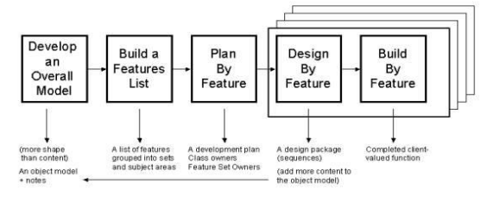

Develop an Overall Model. Researchers present an initial high-level, highlights-only walkthrough of the scope of the system and its context. The domain and development members produce a skeletal model, the very beginnings of that which is to follow. Then the domain members present more detailed walkthroughs. Each time, the domain and development members work in small sub-teams, present sub-team results, and merge the results into a common model, adjusting model shape along the way.

The activity used in Software Development Methodology is conducting a survey. the reason is we are in the middle of pandemic and for the safety of everyone it conducts via google forms. Researchers can count all the votes online so that they can gather data from the survey. If there are some problems like bugs or viruses the researchers can fix the problems ASAP. Furthermore, the researchers gather data in real-time communication with the respondents if there's any doubt about this project.

Build a Features List. In this phase, the team should have a basic understanding of the presented project. The Team should use the overall model to identify which features will be required. Remember that in FDD, ‘features’ are similar to user stories — so think about the development activities which will need to happen to bring your product or software to life. The team should have a basic understanding of the presented project.

Plan by Feature. The next step is to plan by feature. In this phase implementation order of the feature is decided, the team should allocate reasonable estimates to each feature, assign them to a team member and work out what needs to happen for these deadlines to be met. For ultimate success, all team members should take part in this process.

Design by Feature. The team creates different designs with their features. Teams should design concurrently and collaboratively. In this phase, the team should collaborate to create the design and its different kinds of features. The team will make sure that the design will be uniform and will avoid different kinds of chaotic layouts and it will be appropriate to all.

Build by Feature. This is the most important phase in the FDD methodology and it is allotted the longest amount of time to complete the proposed system.

The team should work on their individual build responsibilities at the same time — visual designers on the UI, programmers on coded components, etc. When everything is ready to be pulled together, it’s sent to QA for testing.

**Scope and Delimitation**   
**Scope**

The project "Online Receipt Uploader for Phinma-University of Pangasinan” would focus on the submission of the proof of payment of tuition fees for the students of Phinma-University of Pangasinan. The study will feature the Login Form for the students and Admin access,secretary access, the Dashboard, students module, request module, settings, user accounts module, user logs module, the uploader form, and the Payment history. The system is limited only to the students of the Phinma University of Pangasinan and the Finance Department.

**Delimitation**

The study "Online Proof of Payment" shall not cover the, the distribution of permits, the loan process, and this system is limited only to students and school staff of Phinma-UPang.

# **Data Gathering Techniques**

The researcher used the instruments and techniques that is necessary to complete the development of the Online Receipt Uploader for Students of Phinma-University of Pangasinan which includes interviews, survey questionnaires, and internet research and the construction of evaluation forms for determining the study’s worth and significance.

The data was collected at a time that was most convenient for the respondents and the researcher for interaction, resulting in a higher level of information acquisition that was important in achieving the study's objectives.

Interview. The researcher conducted interviews through social media platforms to understand their insights of Online Receipt Uploader and gather more information and identify the problems that may occur. This interview was made to effectively collect data from the respondents.

Survey Questionnaire. The researcher conducts a survey questionnaire via google forms to help the researchers gather the needed data from the respondents.

Document Analysis. The researchers gathered data and information from the literature review, which supported the researcher to adapt the same document to be used in the Online Receipt Uploader.

**Sources of Data**

Categorized according to unique criteria such as age, gender, and income as a way to analyze the characteristics of a particular group. Analyzing demographic data is essential for businesses, organizations, and governments to make decisions. Using this data, businesses can create marketing strategies and governments can implement public policies. Academic researchers also collect demographic data for research purposes using various survey questionnaires or instruments.

The researcher conducted a survey on 208 students who had already had the experience of using google form. If they have difficulty using the google form and they need an online receipt uploader to have a proper and quick submission of proof of payment of their tuition fee to save more time. Figure 1 revealed that 70% (145/208) of the research participants are most likely to have an Online Receipt Uploader and 30% (62/208) prefer the submission of google form process in submitting their tuition fee receipts.

The researcher observed the Google Form process, which helped researchers identify problems with the current system. Responses gathered from the survey questionnaire from Phinma-Upang students. This is the main source of data in this study. All data collected in the survey questionnaire helped in the development of proposed Online Receipt Uploader.

Demographics are the characteristics of a population

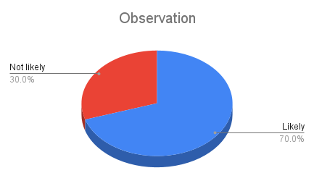

Chapter 3

**DISCUSSION OF FINDINGS**

In this chapter, the researchers will discuss the problems encountered in the existing system, the interpretation of data and discuss the designs and features of the proposed system.

**Issues of the Existing System**

Website for Online Receipt Uploader System.It can address the issues and problem of uploading tuition fee receipts when they pay Online, compared to submitting their tuition fee receipts in Google Form. Despite the implementation of the system, there are still issues and concerns that demands improvement. Focus areas on the current Online Receipt Uploader for Phinma-University of Pangasinan that needs to be improved and will be discussed are a) Receipt Uploader, b) Request Record, c) Student Record d) Payment History.

Receipt Uploader- When a student pays the tuition fee Online, a student's next thing to do is to fill out the needed information and submit the receipt of the tuition fee in the Uploader form, then the admin officer starts to verify the information that the student submits and processes the account of a student.

Below are the issues concerning the Uploading of Receipts:

1) Prolonged processing of receipts. a student who has paid tuition fee Online or in Banks needs to upload a tuition fee receipt and other information on the Form, but it is not processed immediately so the students do not immediately get their permits, and as a result, there are students who are not able to take the scheduled examination immediately because they have not yet received a permit from the finance department.

2) Time Consuming. Time is valuable and must spend productively, rather than waiting to processed receipts.

Request Record- When a student submits a form it will go to the Request Record where you can see the students who submitted the receipts that still needs to be verified and approved if the information submitted is correct, and an Admin officer is the one who is allowed to verify, edit and delete records of the student such as, if the typed amount of tuition fee is correct, and if the image of receipt is correct.

Below are the issues concerning the Request Record:

1. Time-consuming data entry. Data entry takes much time to complete due to alternating actions by the Admin Officer before finalizing the record.
2. Inaccuracy of data. The Admin officer may not understand the submitted information of the form because there is information that is incorrect and does not match the submitted tuition fee receipt, which would eventually lead to inaccuracy of data.

Student Record. The student record is when an Admin officer verifies all the student requests in the Request record, here you will find the final list of students where you can find out who has already paid the Tuition Fee and submitted the receipts after the student paid in Online E-Wallet systems or at the Banks.

Below are the issues concerning the Student Record:

1. Data modification anomaly. Changes to student information may be done even without the knowledge of the student concerned. A student is not informed whenever his status is modified by the Admin officer.

Payment History. In the payment history, you will see the information that you submitted in the form containing personal information and the receipt of the tuition fee you paid, and it will also show if the receipt you submitted has been processed and verified by the Admin officer. you can also see here what semester and school year you paid.

Below are the issues concerning the Student Record:

1. Time-consuming. Time is valuable and must spend productively rather than waiting to approve and process the submitted tuition fee receipt and wait for the distribution of permits.

**Features of the proposed system**

The information gathered by the researcher assists in the development of the proposed Online Receipt Uploader for Phinma-University of Pangasinan including its advantageous effect on the people involving its operations. The features also intend to respond to the concerns regarding the issues identified in the existing system.

Receipt Uploader- This feature focuses on the Uploading of receipts after a student pays their tuition fees in the Online E-Wallets and Banks. The admin officer is capable of managing the students' accounts whereas the students can view their profiles and in case of errors or irregularities on the information, they could immediately contact the admin officer for modification.

Figure 1 shows the events included in this feature like: the uploading of receipts, with personal details which include First name, Last name, student number, email, contact number, periodic type, amount of the tuition fee and the submit button.

Figure 1.

Uploading of Receipts in Upload Module

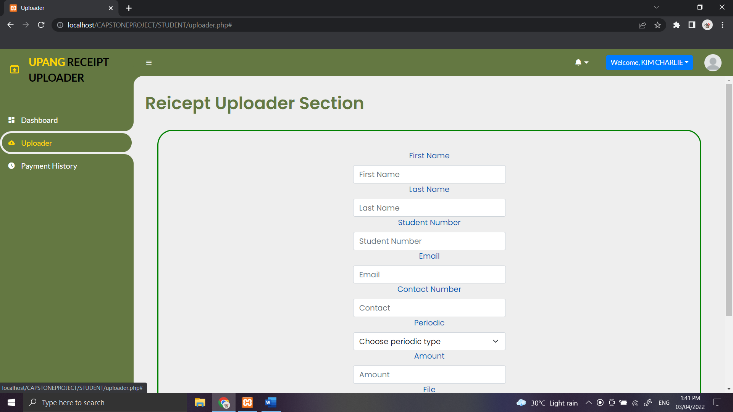

Figure 2 illustrates the the view list of the filtering and validation submitted form by the students in the Admin Dashboard

Figure 2.

List of Students on the admin account

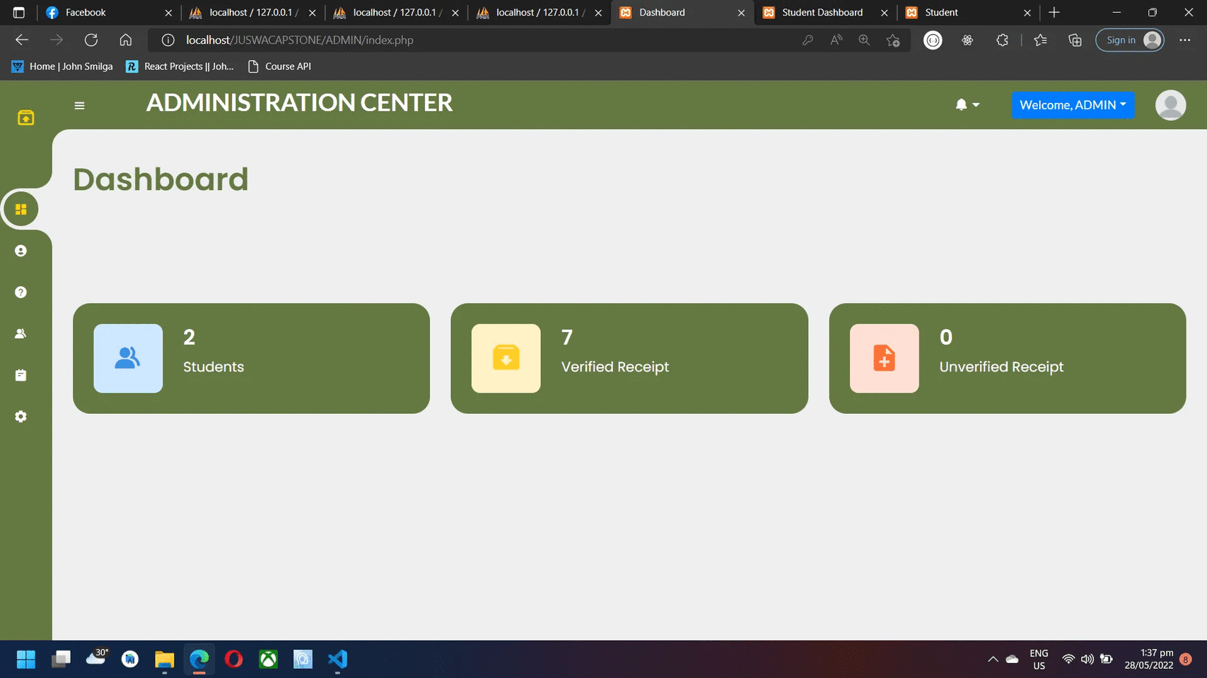

Data entry for uploading of tuition fee receipts would be faster as the student is informed an ability to see his record as the admin officer encode it, furthermore making the data accurate.

Request Record- This is an important feature that focuses on the verifying, editing and deletes the record of the student after they fill out and submit tuition fee receipts because here, you can see the students who submitted the receipts that still need to be verified if the information submitted is correct.

Activities in this feature include:Verifying, Editing and deleting personal information and submitting tuition fee receipts with the approved button, by Clicking, it will notify the students that the receipt has been verified.

Figure 3.

Request Record in the Admin Account

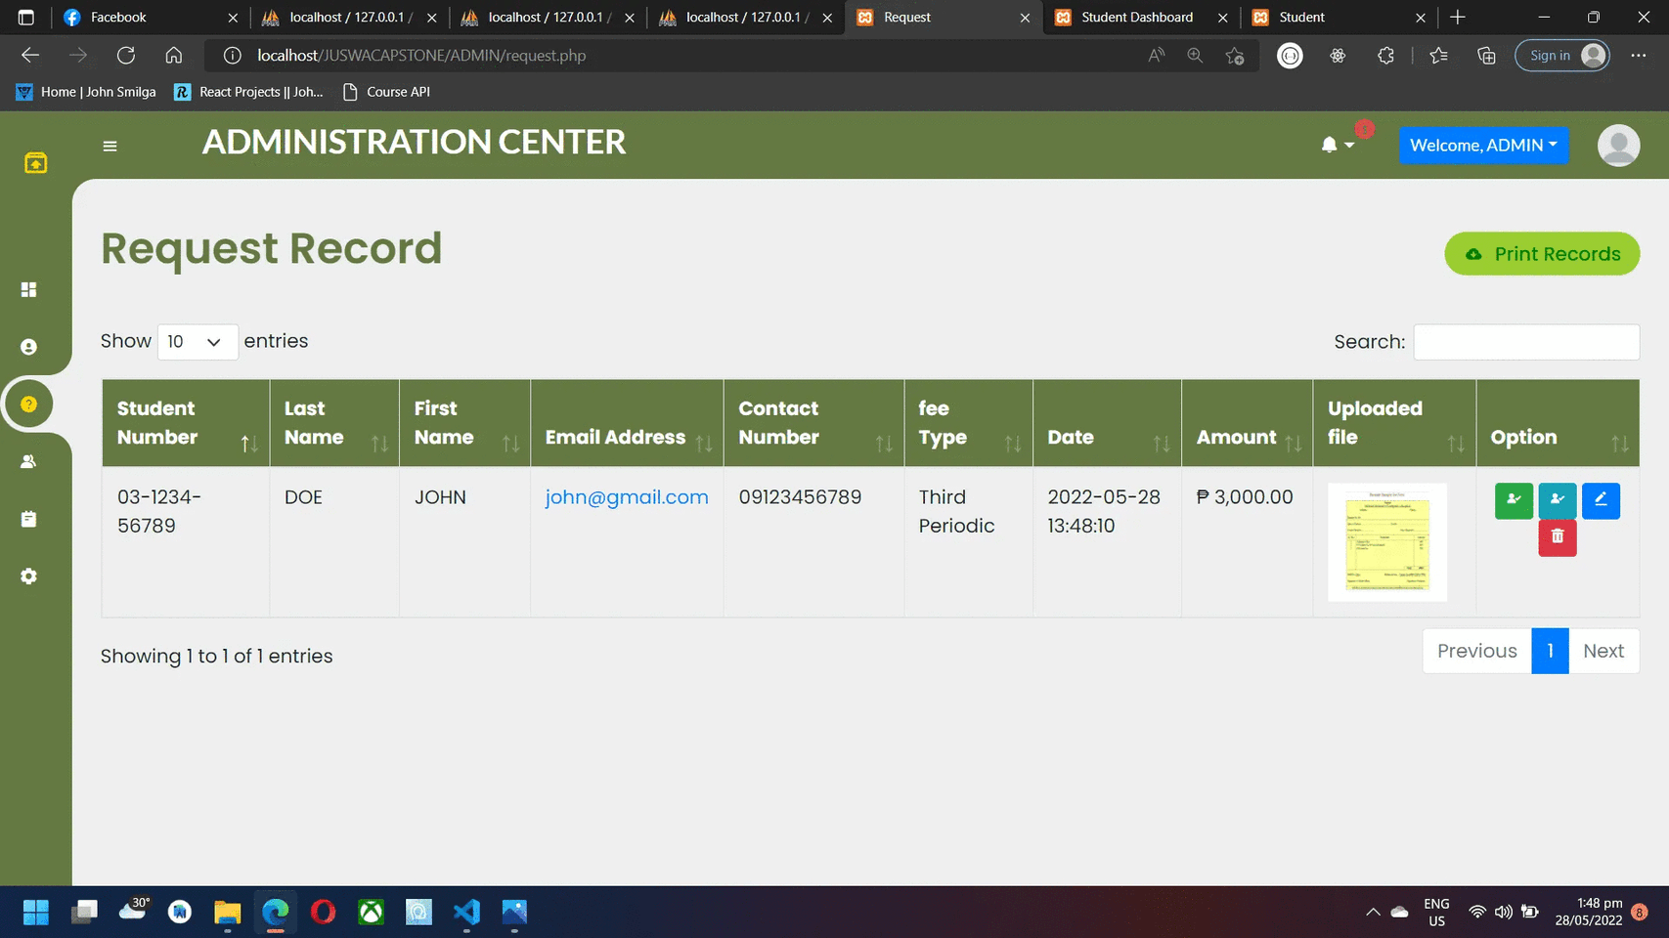

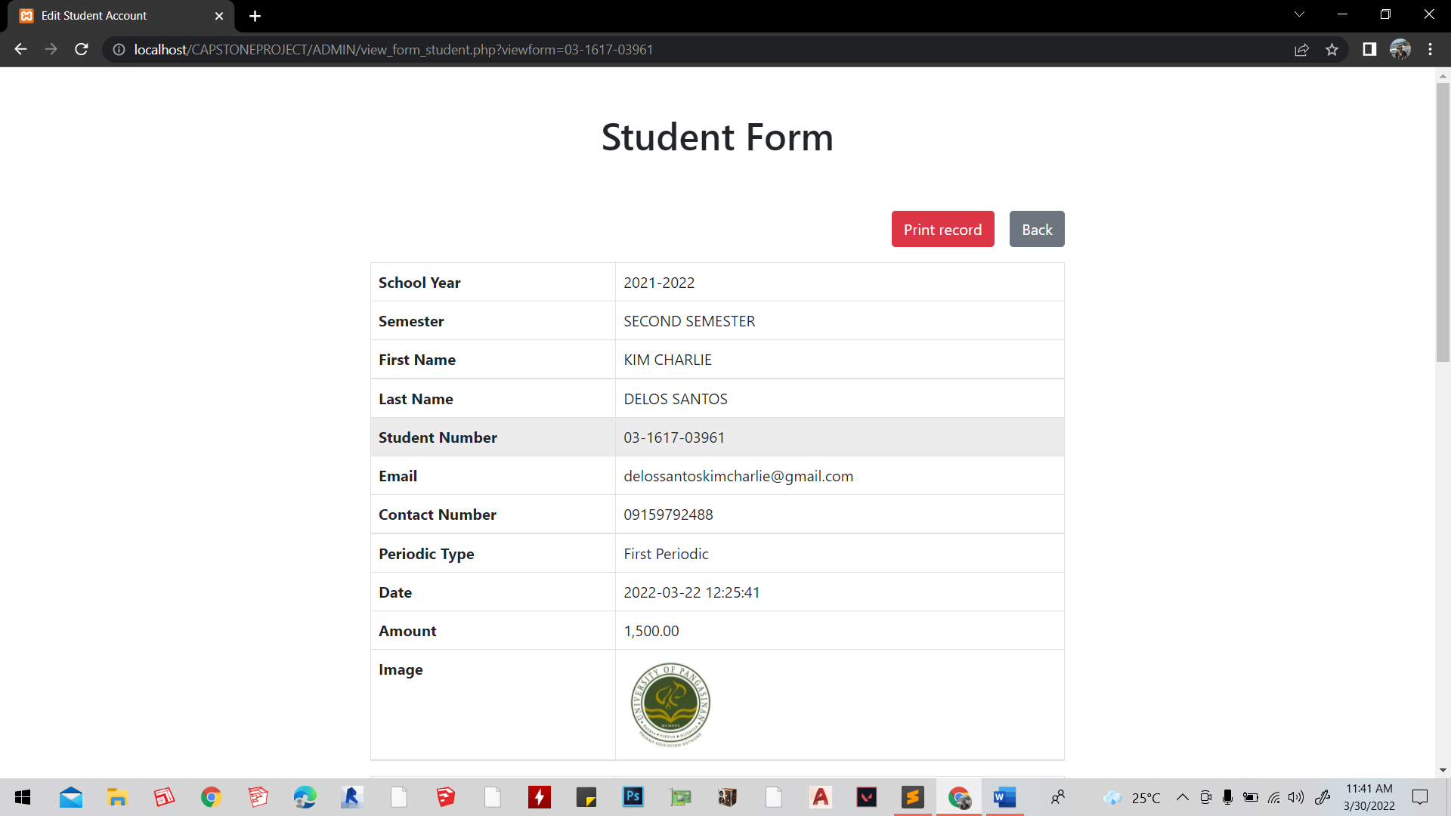

Figure 3. illustrates the submitted information of the student with the following features: view list of Last name, First name, Student number, Email address, Contact number, Fee type, Date, amount of tuition fee, Uploaded file and the option, and also on how the admin officer can edit the submitted information by the student.

Student Record- This feature is intended to monitor the record of students, when an Admin officer verifies and approved all the student requests in the Request record, here you will find the final list of students where you can find out who has already paid the Tuition Fee and submitted the receipts after the student pay Online E-Wallet systems or at the Banks.

Activities included in this feature, as shown in Figure 4, are: the list of approved submitted personal information and the receipts of tuition fees.

Figure 4.

Report on Student Records

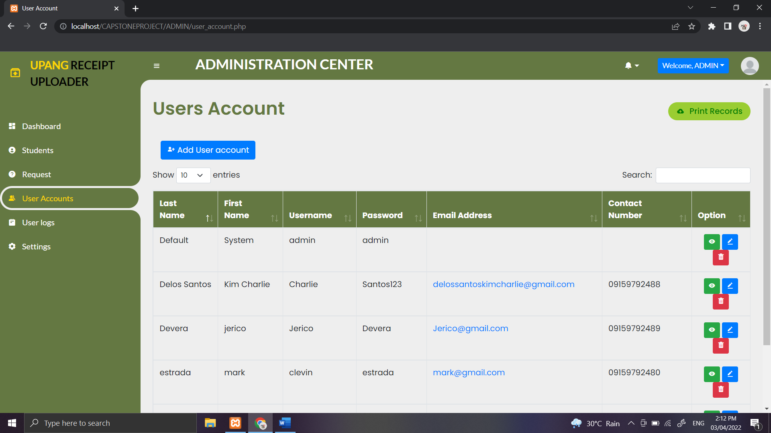

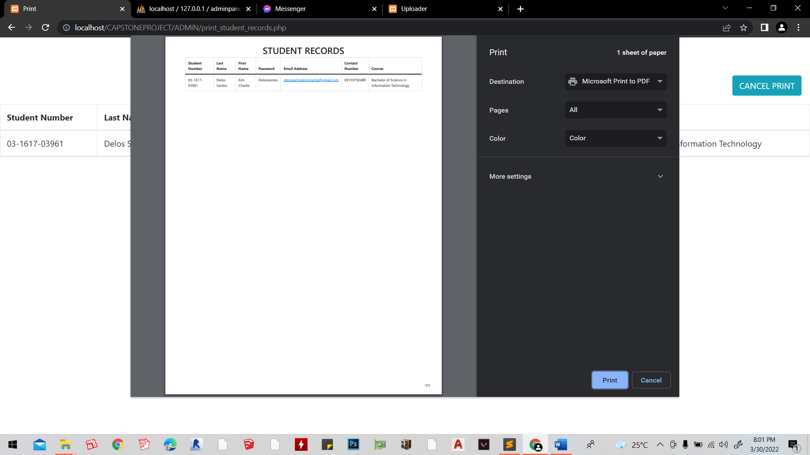

Viewing the List of approved and verified students who submitted their tuition fee receipts.

Payment History. This feature is intended to view the transaction history of your tuition fee payments, including the information that a student submitted and the receipt of your tuition fee.

Figure 5 shows the event where you can see your submitted form including the personal information and receipt of your tuition fee that has been processed and approved by the admin officer.

Figure 5.

Payment History for student account

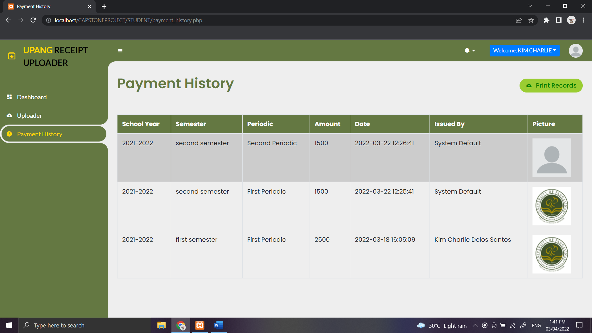

Other features include:

Figure 6.

Log in for Student account 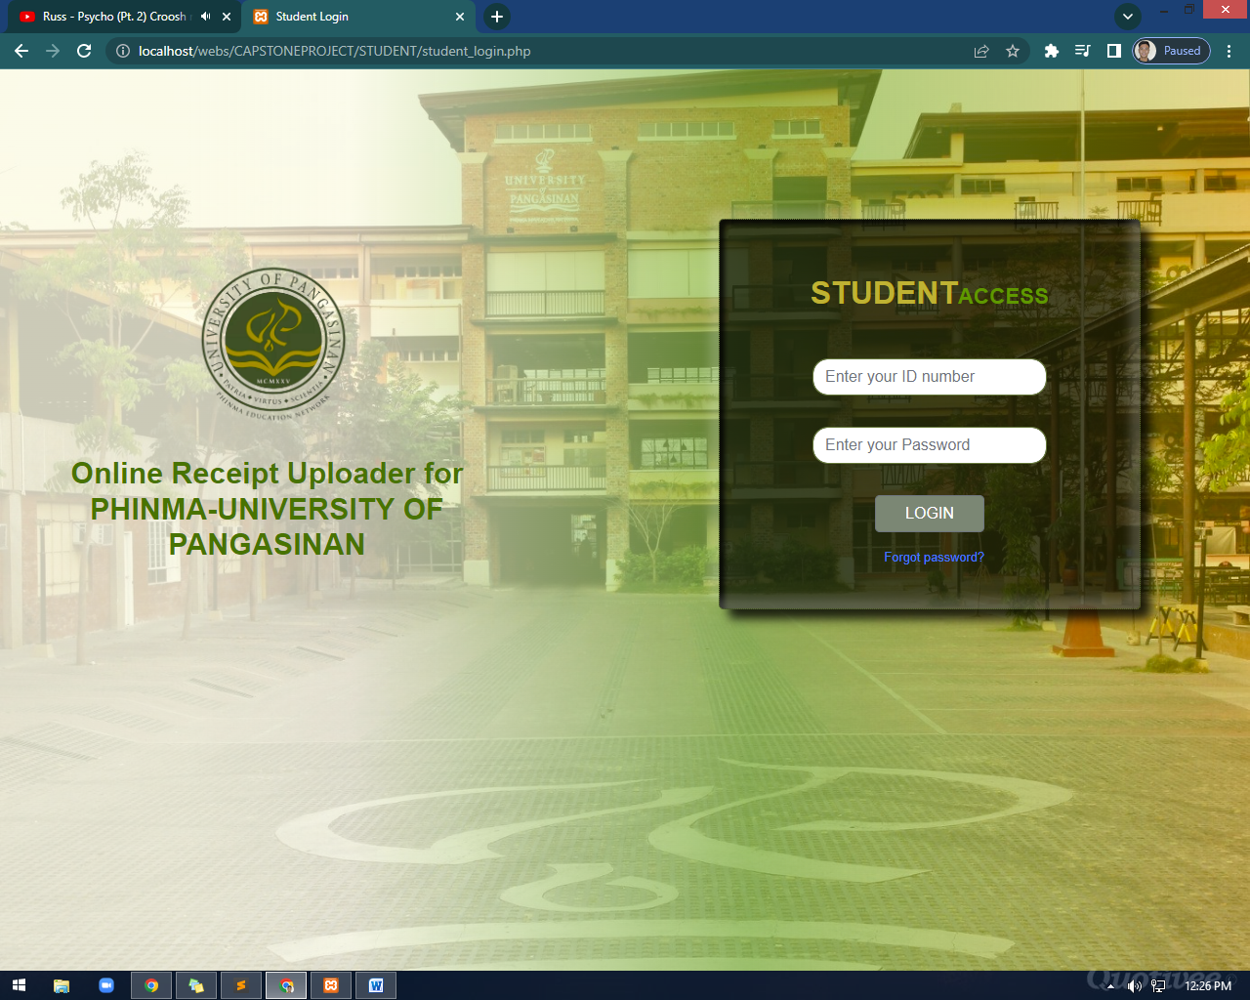

Forgot Password for student account

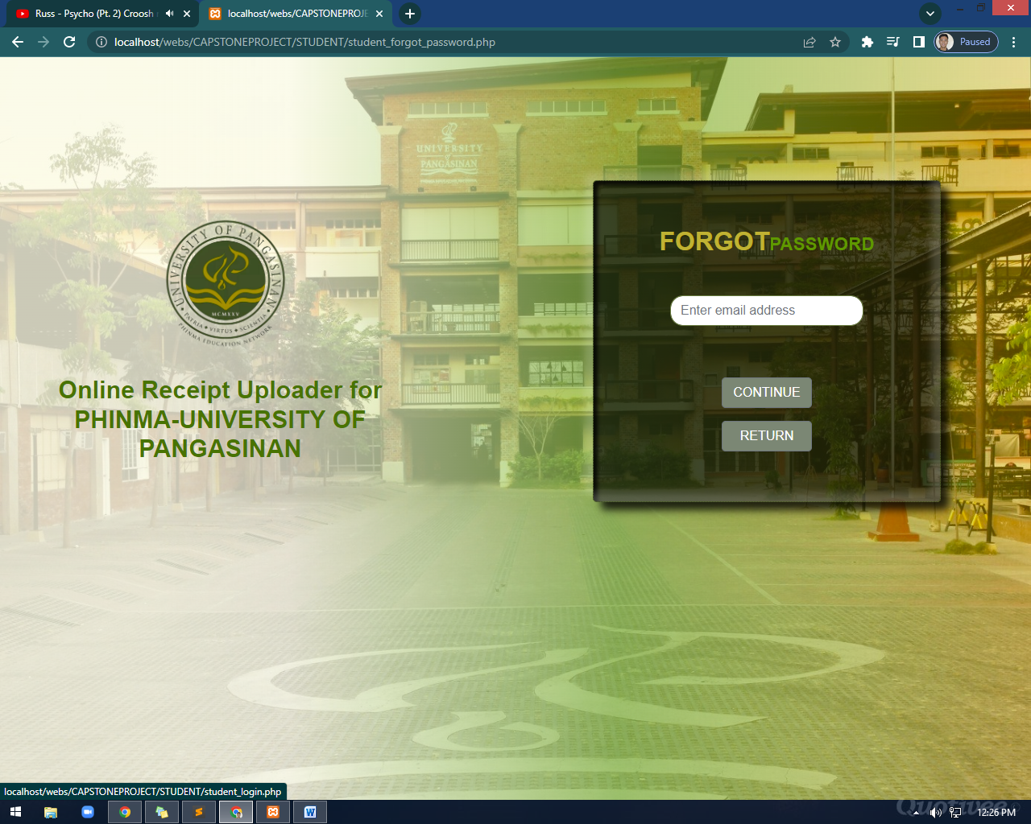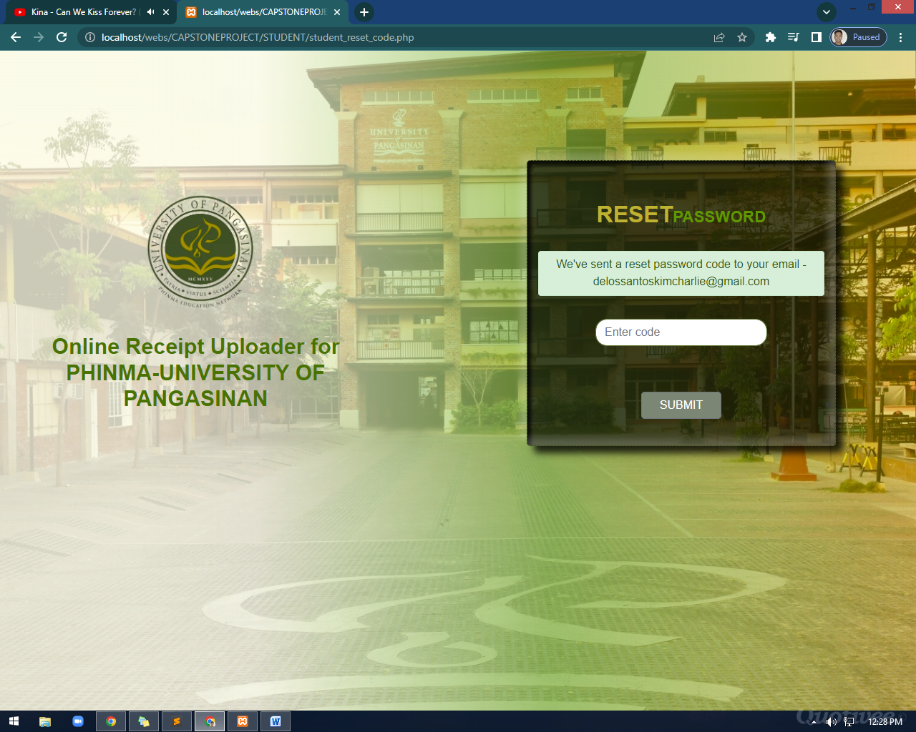

Figure 7.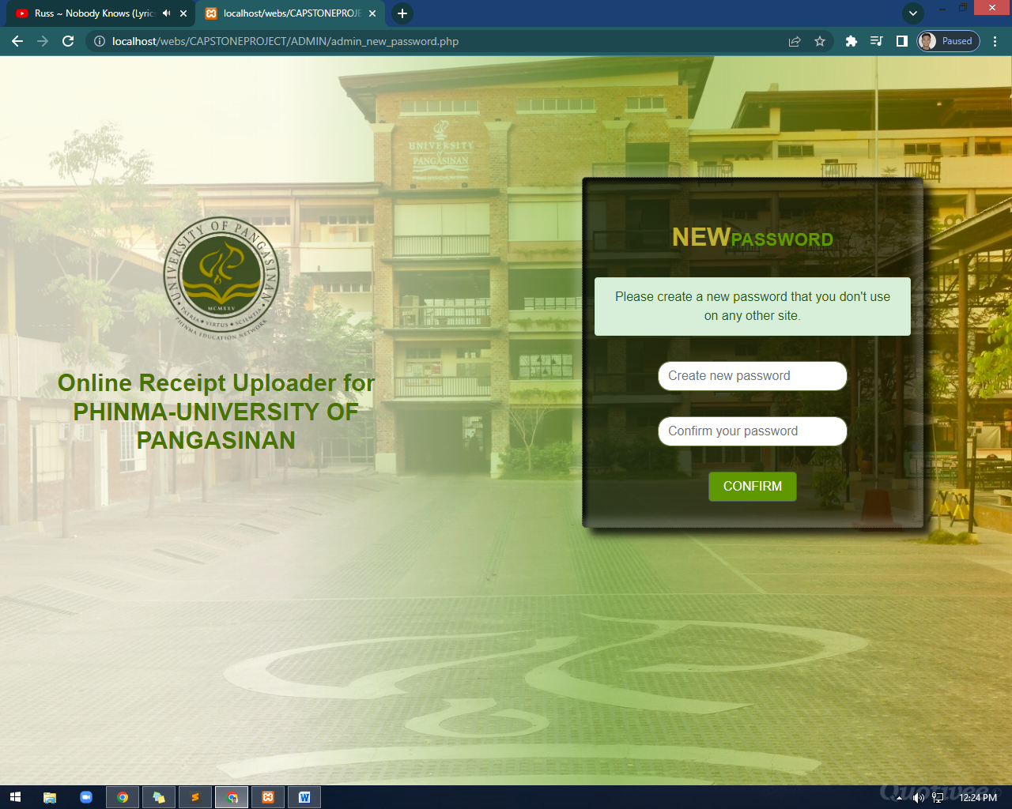

Student Dashboard

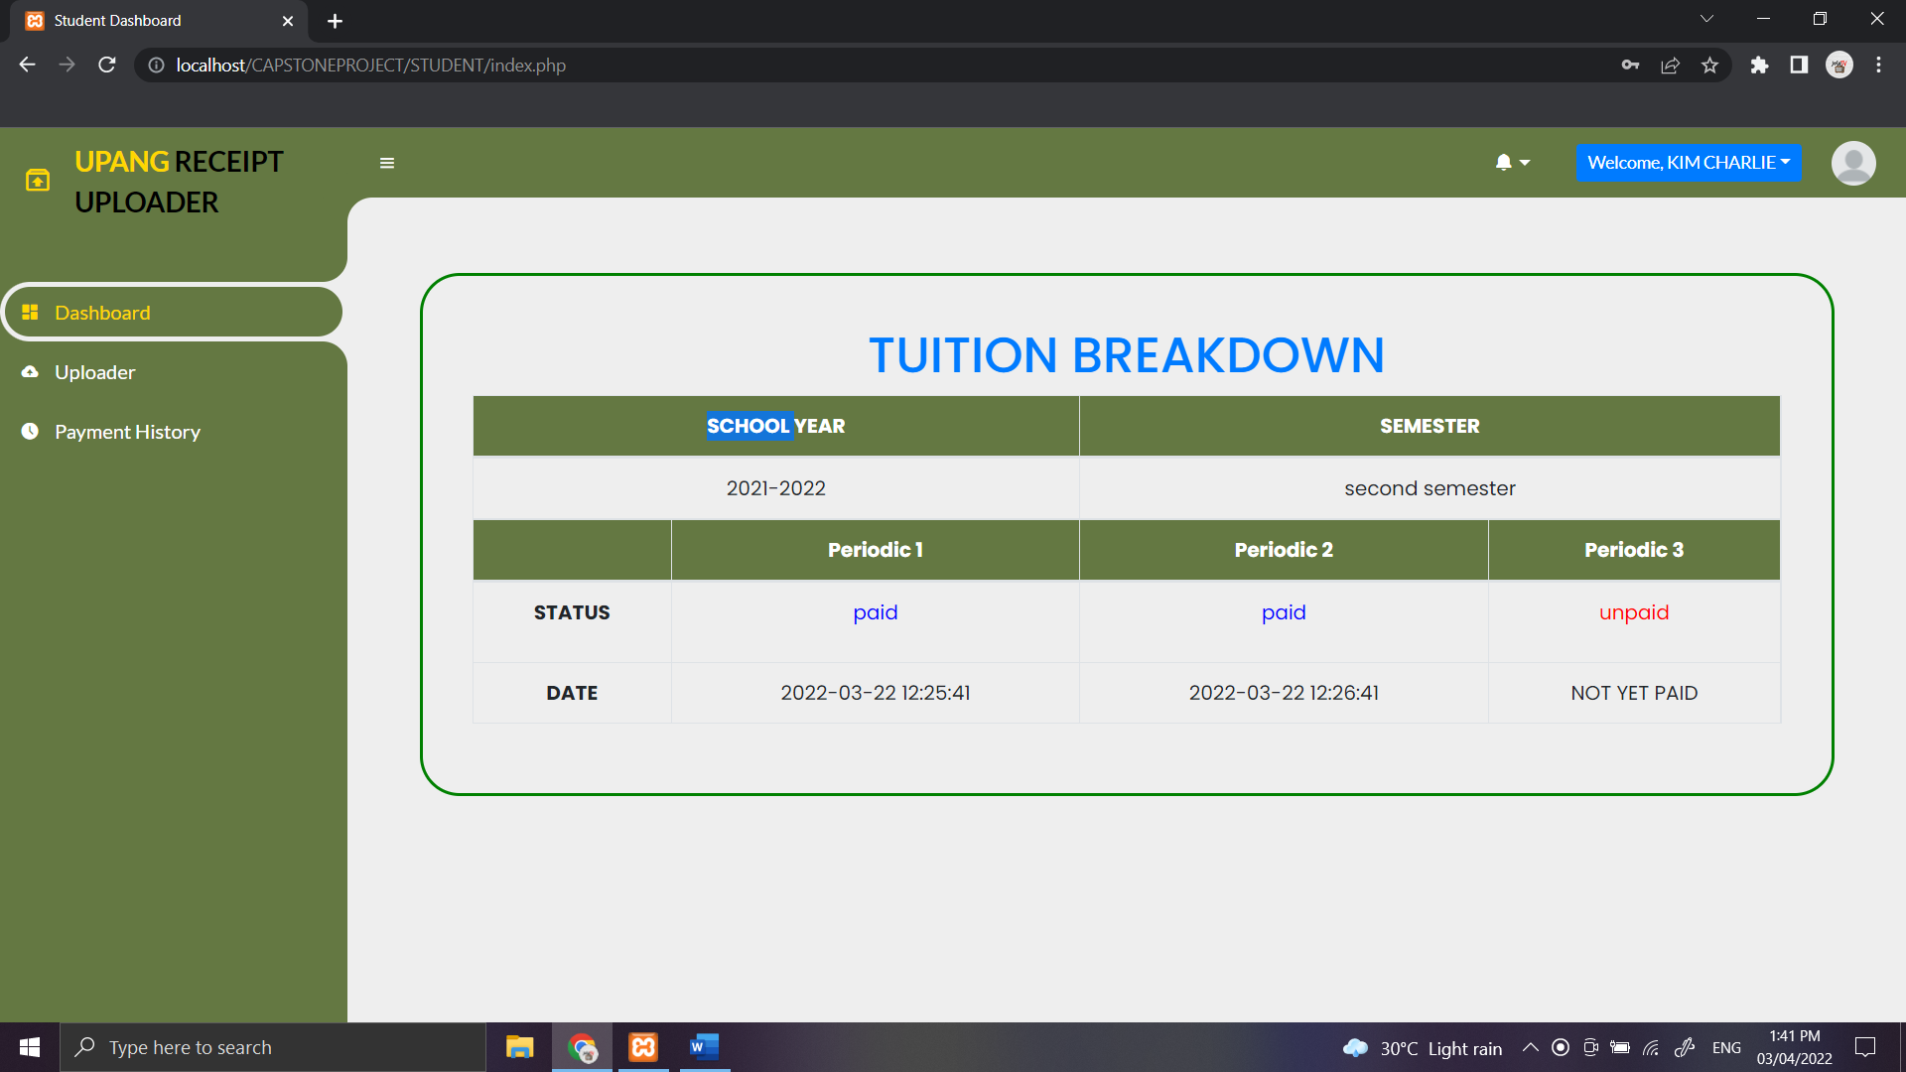

Figure 8.

Student Profile

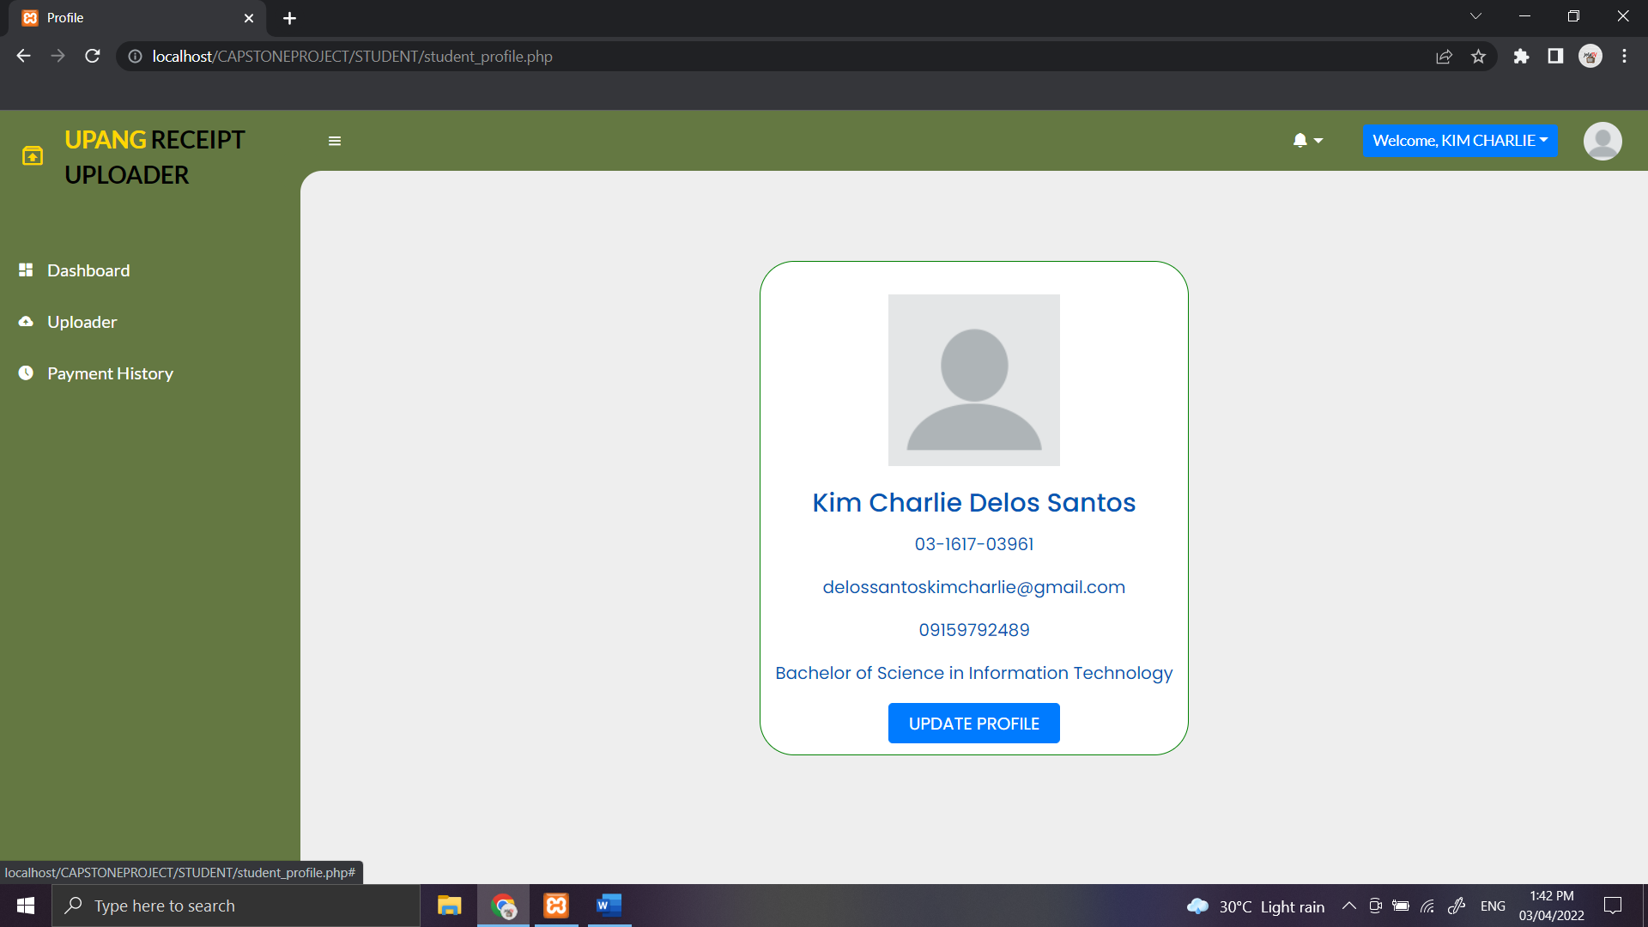

Figure 9.

Admin Log in

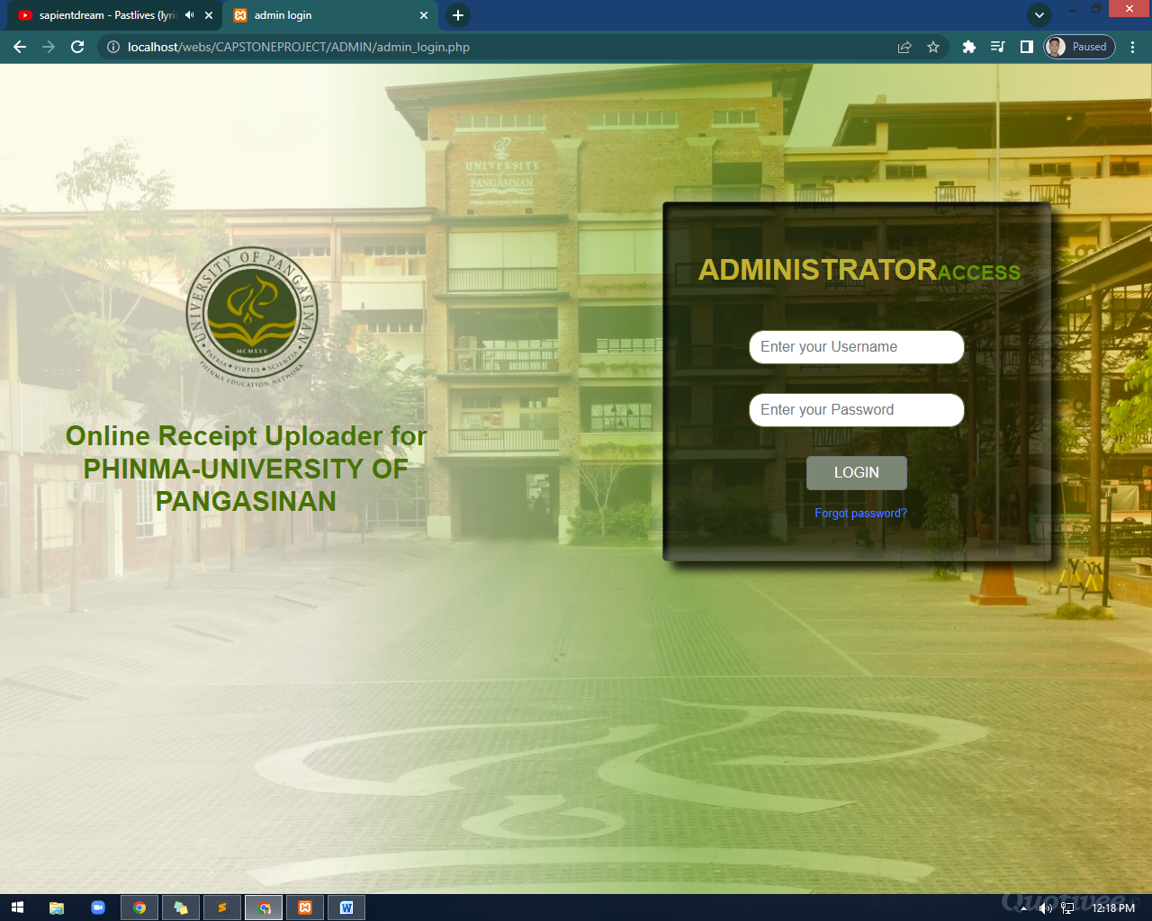

Figure 10.

Admin Dashboard



Figure 11.

Admin Profile

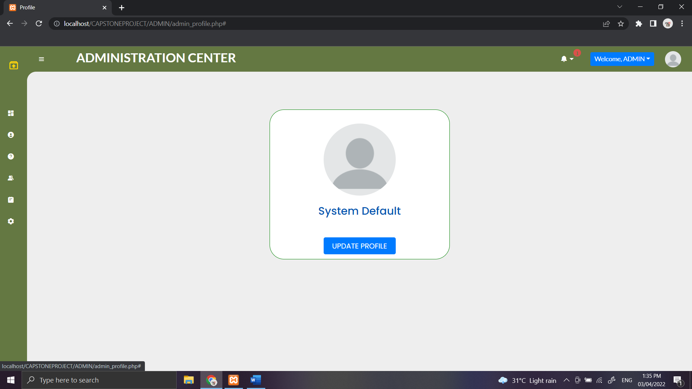

Figure 12.

Admin Users Account



Figure 13.

Admin Users Logs

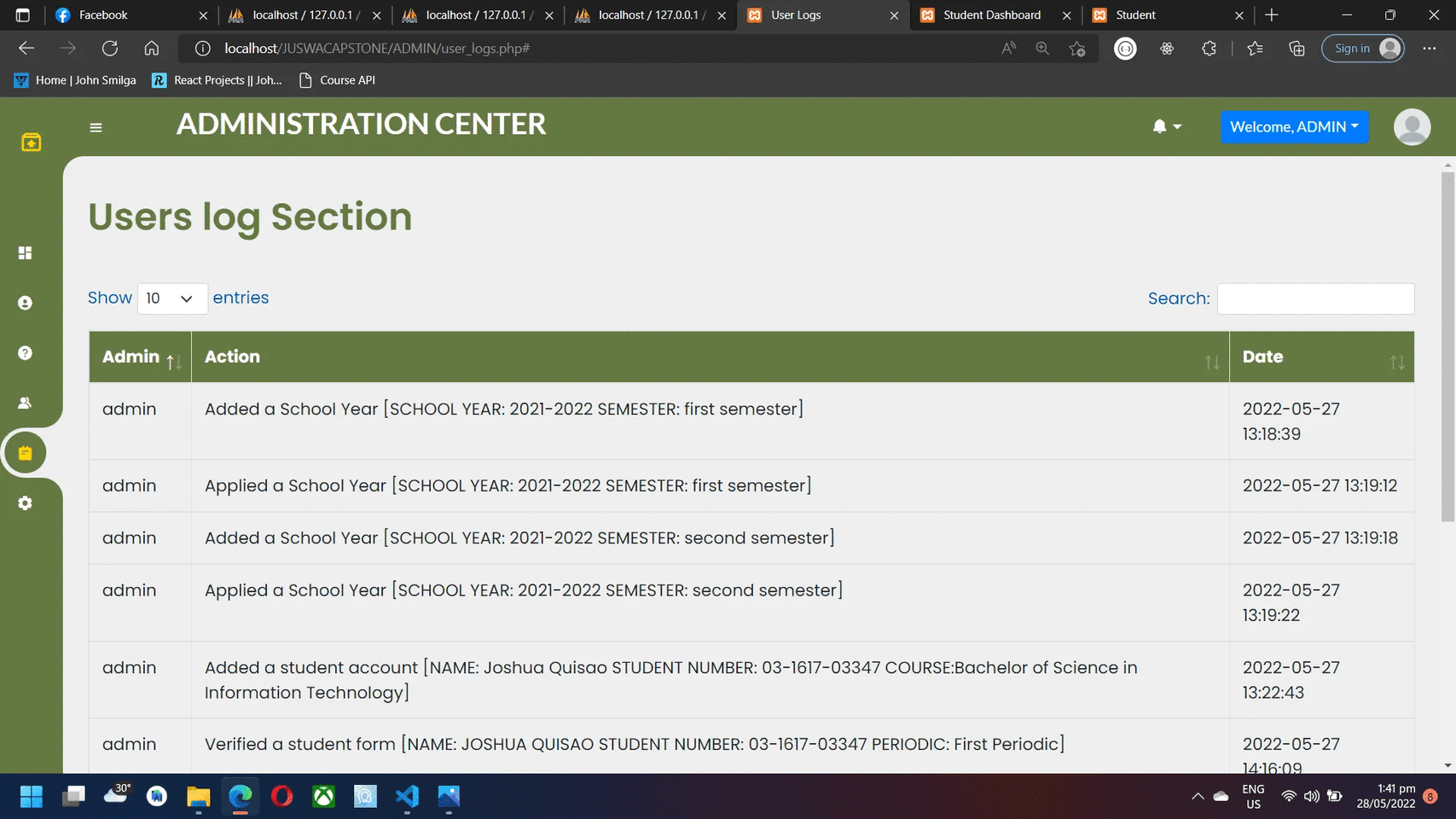

Figure 14.

Settings

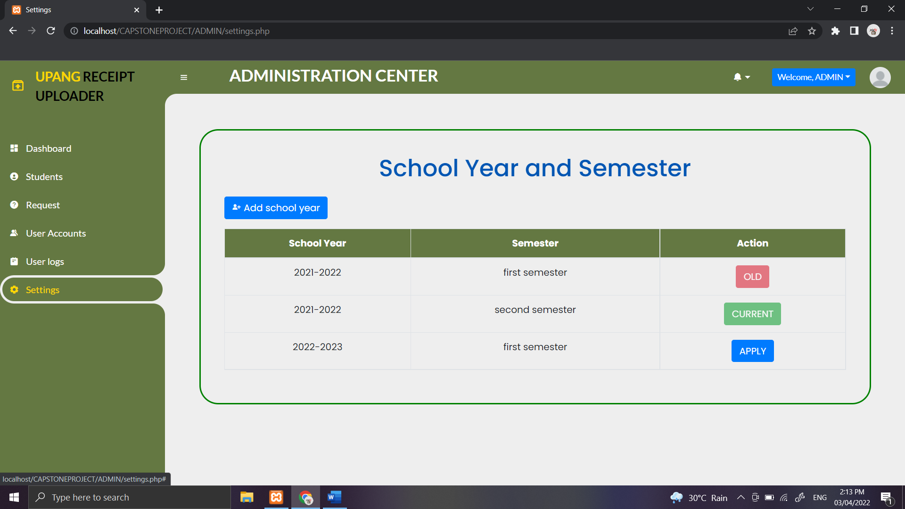

Figure 15.

Secretary Log in

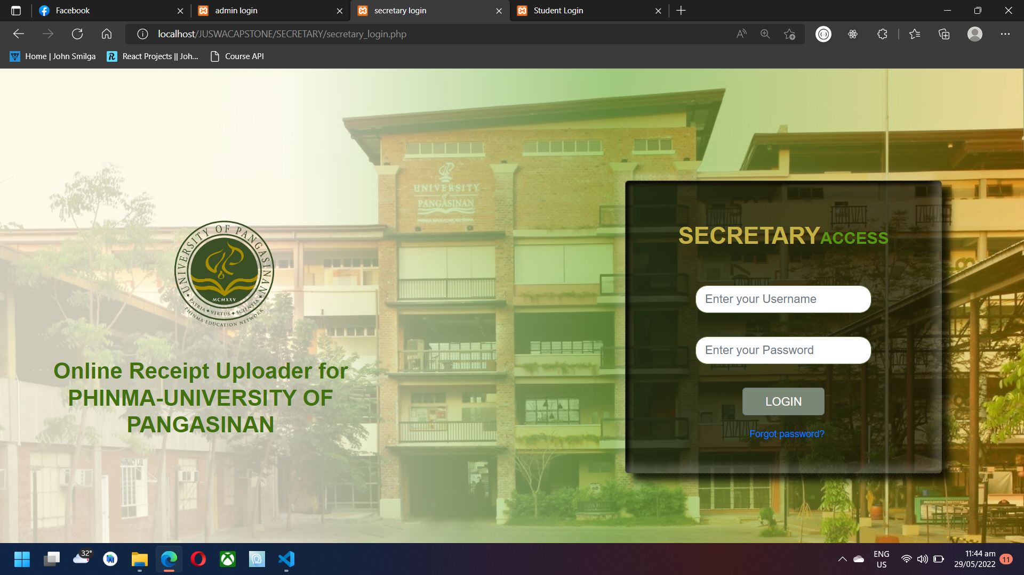

Figure 16.

Student Permit Record

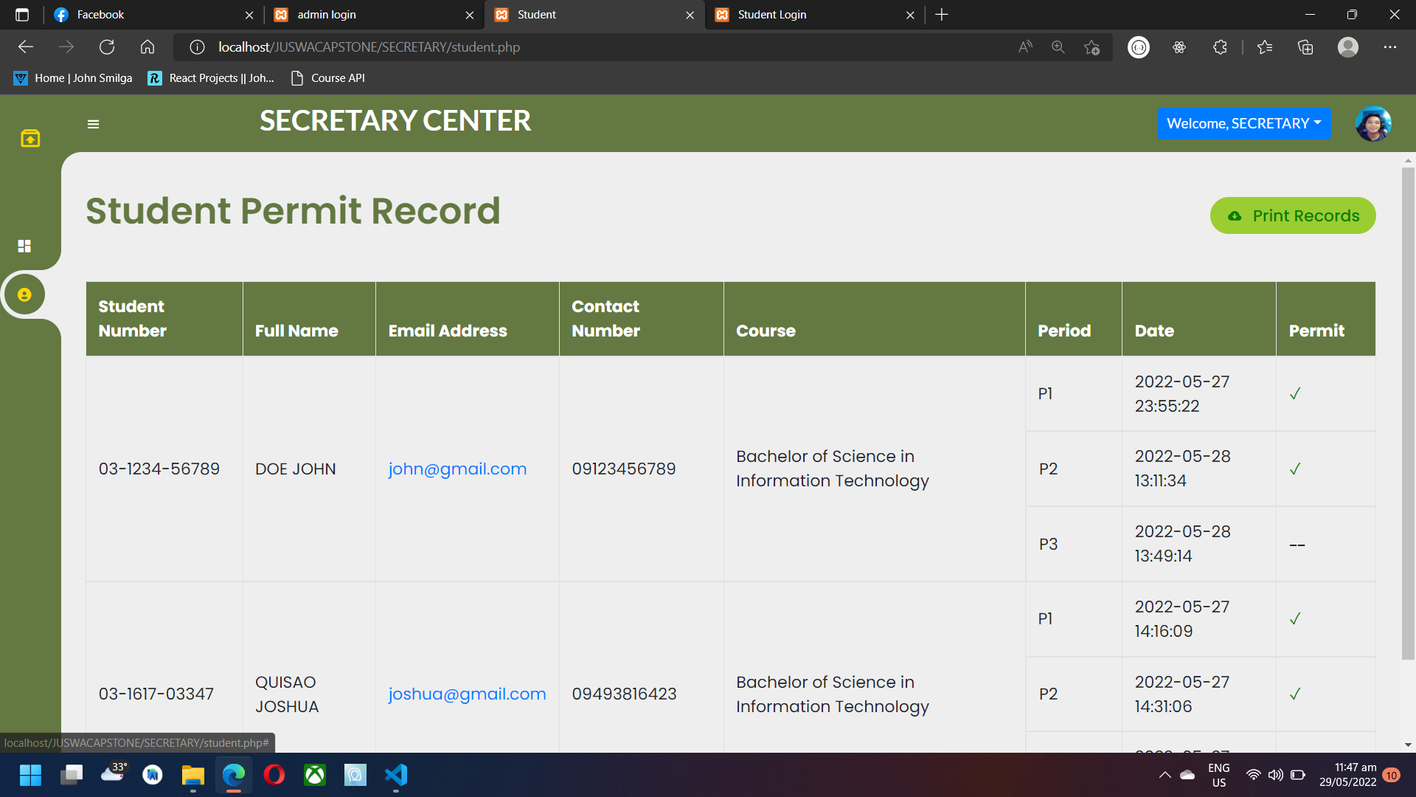

**Acceptability level of the proposed system**

Level of acceptability is the measurement of how

acceptable a new system is to the community and prospect

people who might be affected by its implementation.

The means to determine the level of acceptability for this study is through the utilization of a survey questionnaire. The questionnaire consisting of four major parameters for measurement namely usefulness, ease of use, ease of learning, and satisfaction will be used as the statistical tool, and the rating scale to interpret the weighted mean for each parameter will be the Likert-type scale. A Likert scale provides a great way of measuring attitudes, knowledge, perception, values, and behavior changes. A Likert-type scale involves a series of statements that survey respondents may choose from in order to rate their responses to evaluative questions. The five-point Likert scale for measuring the level of acceptability is used to analyze the students’ observation and experience in using the proposed system where the rate scale are as follows: 1 -Totally Unacceptable, 2- Unacceptable 3 –Neutral, 4 – Acceptable, and 5 – Totally Acceptable.

The weighted mean for the rating per item is also calculated to be able to analyze the scale and helpful information for the measurement of the level of acceptability. A weighted mean differs from an average in that a weighted mean return is a number that depends on the variables on both value and weight while an average is a number that expresses the central or typical value in a set of data. Computation for the weighted mean was done with the formula: Sum of all rating scale value (1-5) multiplied its corresponding number of rating (0-208) per item divided by the total number of ratings.

Usefulness. It is related to whether a tool or software is appropriate to the tasks and needs to and needs of the target user. The tool may be effective and efficient, but if users have no use for it then it, then it has negligible impact.

Table 1 reveals that the item no. 3, “It is useful”, had the highest number of ratings with One hundred and forty-one (141) for a totally acceptable rating of 5. Respondents find the system to It doesn't take much time when they use it and it helps them in making more productive which gained the second and third for the highest rating of totally acceptable, having the rate numbers of 131 and 130 respectively. One hundred twenty (120) respondents gave a perfectly acceptable rating for the item that It makes them easier to do the tasks they wish to complete, The item “It enables me to work more efficiently” has the lowest rating of the highest scale including a rating to the scale of “unacceptable” with two (2) for each item. It has values among all items with a rating scale of 2 (unacceptable) and 1 (totally unacceptable) which is not a positive reaction for the system.

Table 1.

Table of Level of Acceptability for Usefulness

| **No.** | ITEM | 5 | 4 | 3 | 2 | 1 |
| --- | --- | --- | --- | --- | --- | --- |
| **1.** | It enables me to be more productive. | 126 | 52 | 18 | 9 | 3 |
| **2.** | It enables me to work more efficiently | 84 | 91 | 28 | 2 | 3 |
| **3.** | It is useful | 141 | 43 | 17 | 4 | 3 |
| **4.** | It makes it easier for me to do the tasks I wish to complete | 120 | 60 | 23 | 3 | 2 |
| **5.** | It doesn't take much time when I use it | 131 | 50 | 23 | 2 | 2 |

Figure 17 shows that the item “it is useful” have

garnered the highest weighted mean of 4.51 for the usefulness parameter. This item is considered to be one of the most important items for this parameter because this would somehow reveal the perception of the respondents whether the system is useful or not in general. Respondents affirms that the system makes it easier for them to do the tasks that they wish to complete and It doesn't take much time when they use it with the weighted mean of 4.40 and 4.47 respectively. The two items with the least weighted means of 4.38 and 4.20 are “It enables me to be more productive” and “It enables me to work more efficiently”. The factor that seems to make these items have the least weighted means is the respondent’s differing wants and expectations. Despite having the least value, it is still considered to be a high value of a weighted mean for an item.

Figure 17.

Weighted mean for Usefulness

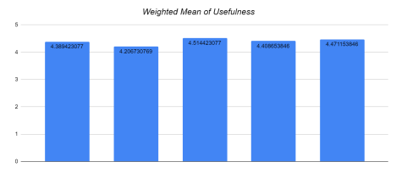

Ease of Use. It can be defined as the amount of effort which subjects expend executing and/or accomplishing a particular task. Ease of use is closely related to efficiency which if a tool is not easy to use, then it is likely to result in efficient use.

Table 2 reveals that the item “I can use it successfully every time” got the highest number of rating for the totally acceptable, while the item with the least rate for the same scale is “It is adaptable”. Three of the items have a neutral rating which is the least rated scale, and these items are “It is user-friendly”, “It is flexible”, and “The interface of the system is pleasant”.

Table 2.

Table of Acceptability for Ease of Use

| **NO.** | ITEM | 5 | 4 | 3 | 2 | 1 |
| --- | --- | --- | --- | --- | --- | --- |
| **6.** | It is user-friendly | 123 | 64 | 16 | 3 | 2 |
| **7.** | It is adaptable. | 119 | 61 | 19 | 5 | 4 |
| **8.** | It is flexible | 121 | 60 | 19 | 4 | 4 |
| **9.** | I can use it successfully every time | 130 | 54 | 17 | 3 | 4 |
| **10.** | The interface of the system is pleasant. | 128 | 55 | 16 | 4 | 5 |

Figure 18 shows the items “It is user-friendly”, and “I can use it successfully every time”, have the highest weighted means for this parameter with both 4.46 respectively. This is a positive indicator for this parameter involving the approval of a good design and some properly programmed functionalities. The item “The interface of the system is pleasant”, get the third highest weighted mean with 4.43 which is a good rating that may involve a positive result in a new user’s experience.

“It is flexible”, had 4.4 and “It is adaptable” got 4.38 are the two items with the least weighted mean for this area. One reason for the least rating of the item is that users usually reset the whole process from the beginning despite the mechanism for error recovery.

Figure 18.

Weighted mean for Ease of Use.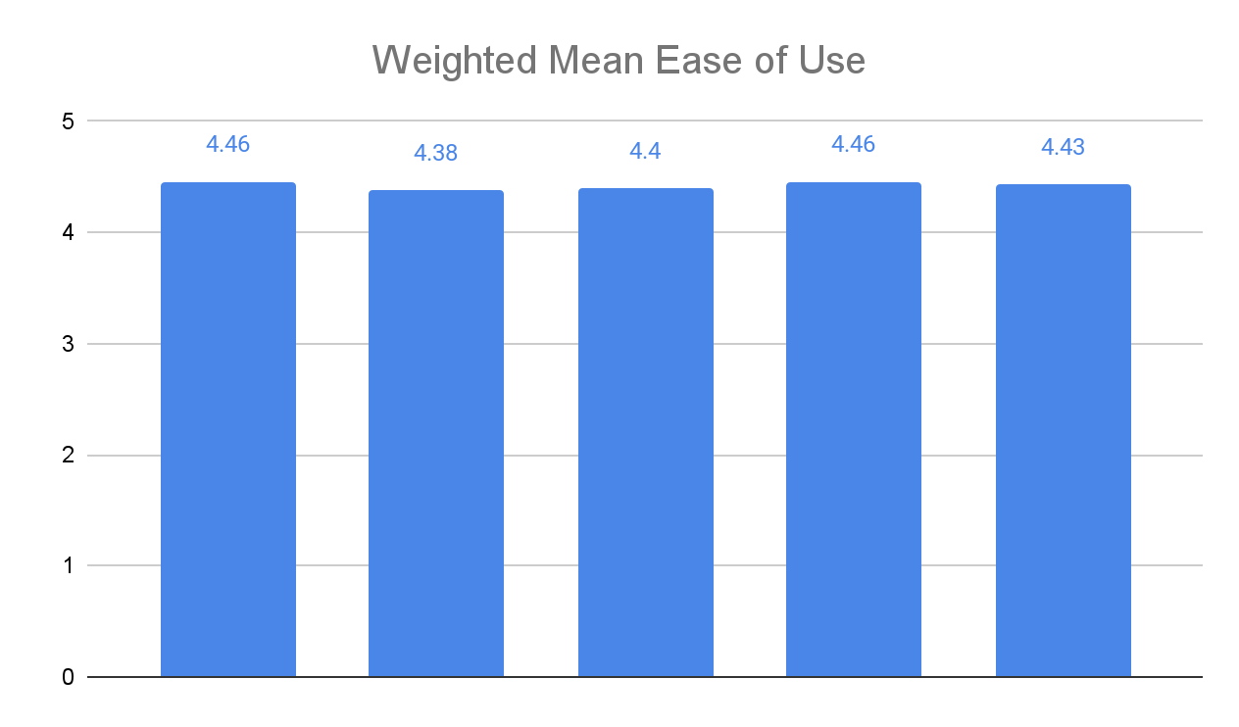



Ease of Learning . This is related to the amount of effort subjects expend learning to use a system. Ease of learning items typically attempts to answer how easy to learn and operate a system for use. A system maybe to use it quickly and can easily recover from the errors, but if it is intended to have a human user and that user cannot learn to use it because it is too complex, then the system may not be successful.

Table 3 shows that all four items for this parameter got shows that the item “It is simple for me to learn how to operate the system” had the highest number of ratings with One hundred twenty-eight (128) for the totally acceptable rating of 5. “I learned to use it quickly”, and “It is simple for me to recall how to use the system to complete tasks” which gained the second and third highest ratings of totally acceptable, having the both rate numbers of 126 respectively. “I can use it without written instructions” got the lowest rating of totally unacceptable.

Table 3.

Level of Acceptability for Ease of Learning

| **No.** | ITEM | 5 | 4 | 3 | 2 | 1 |
| --- | --- | --- | --- | --- | --- | --- |
| **11.** | It is simple for me to learn how to operate the system | 128 | 60 | 12 | 4 | 4 |
| **12.** | I learned to use it quickly | 126 | 62 | 13 | 4 | 3 |
| **13.** | It is simple for me to recall how to use the system to complete tasks | 126 | 58 | 19 | 5 | 3 |
| **14.** | I can use it without written instructions. | 123 | 61 | 15 | 6 | 3 |
| **15.** | I can easily recover from the errors. | 122 | 59 | 17 | 6 | 4 |

Figure 19. reveals a generally high weighted mean value for this parameter where the item “It is simple for me to recall how to use the system to complete tasks” had the highest value of 4.48, followed by the “I learned to use it quickly” and, “It is simple for me to learn how to operate the system” items with 4.46. The least weighted mean of 4.38 was reflected in the “I can easily recover from the errors” item. Continuous usage of the system might positively adjust the weighted mean for that item.

Figure 17.

Weighted mean for Ease of Learning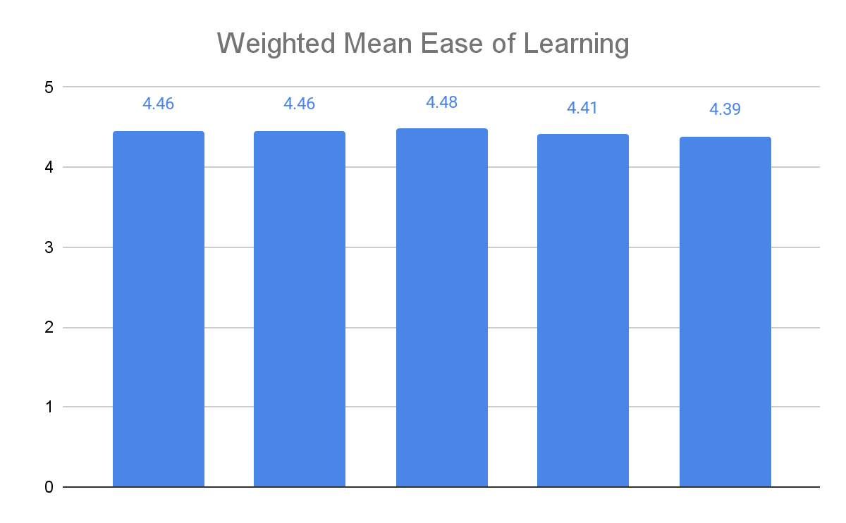



Satisfaction. Satisfaction is the attempt to gauge

subjects’ feelings about their interactions with the system.

Table 4 shows that 134 out of 208 gave a perfectly acceptable rating for the “I feel like I need to use it” item garnering the highest value for this parameter. One hundred thirty-one (131) respondents gave the highest rate agreeing that It works the way they want it to work. “I am satisfied with it” item got (124) for the acceptable scale. Two items (2) got the neutral scale and those are “It is fun to use”, and “I would recommend it to a friend”, which also got the least rate for perfectly acceptable scale with One hundred twenty-two (122) and One hundred twelve (112) respectively

Table 4.

Table of Acceptability of Satisfaction

| **NO.** | **Items** | **5** | **4** | **3** | **2** | **1** |
| --- | --- | --- | --- | --- | --- | --- |
| **16.** | I am satisfied with it. | 124 | 60 | 18 | 2 | 4 |
| **17.** | I would recommend it to a friend. | 112 | 68 | 22 | 3 | 3 |
| **18.** | It is fun to use. | 122 | 59 | 18 | 6 | 3 |
| **19.** | It works the way I want it to work. | 131 | 55 | 16 | 3 | 3 |
| **20.** | I feel like I need to use it. | 134 | 45 | 21 | 4 | 4 |

Figure 20 displays that respondents approved that It works the way they want it to work with the system having the highest weighted mean for this parameter with 4.48. It is followed by the item “I feel like I need to use it” with a 4.47 weighted mean which serves as a positive action in connection to the system. “I am satisfied with it” got a 4.43 weighted mean indicating that system design and functionality effects were properly implemented for general users. The item “It is fun to use” got a 4.39 weighted mean. The item with the least weighted mean of 4.36 is the “I would recommend it to a friend” to which different needs and wants of the users have been applied in user experience.

Figure 20.

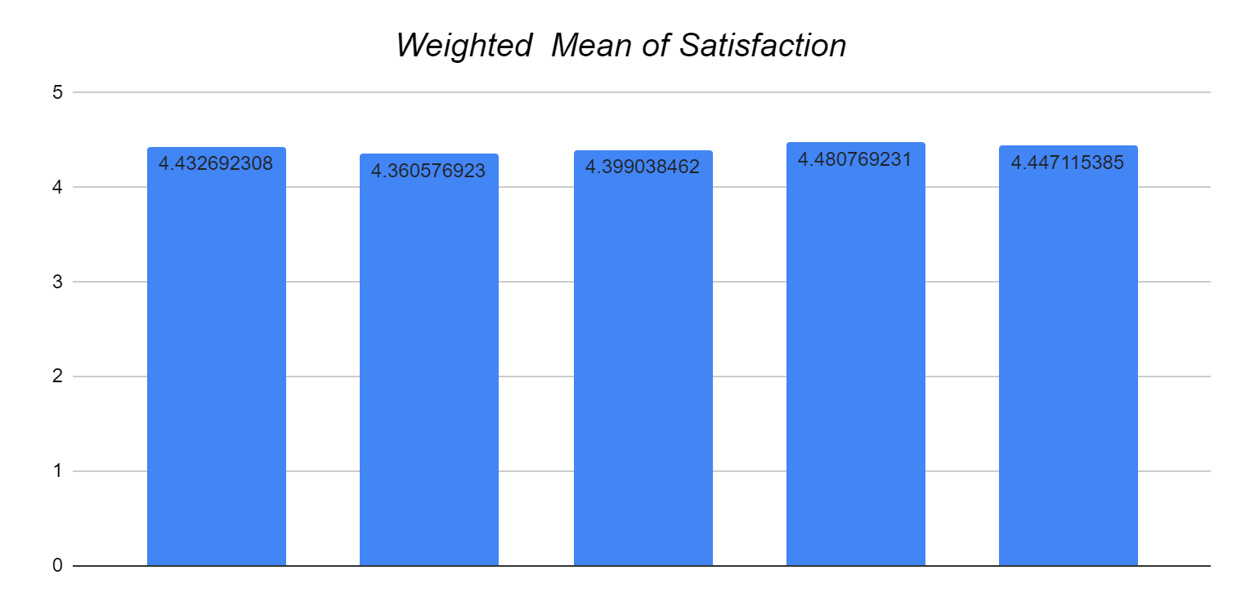Weighted mean for Satisfaction



Table 5 shows the weighted mean definition used for the interpretation of the ratings gathered from the questionnaires which are answered by the respondents. The remark for the weighted mean value was taken from the Likert-type scale for measuring the level of acceptability.

Table 5.

Likert-type Scale Definition for Level of Acceptability

| WEIGHTED MEAN VALUE | REMARK |
| --- | --- |
| 1.0-1.9 | Totally Unacceptable |
| 2.0-2.9 | Unacceptable |
| 3.0-3.9 | Neutral |
| 4.0-4.9 | Acceptable |
| 5.0-5.9 | Totally Acceptable |

Table 6 shows the summary of the weighted mean for all

parameters in measuring the level of acceptability of the

system and it also includes the overall average and

corresponding remark based from the Likert-type scale

definition. It reveals that the Ease of Learning parameter had the highest overall weighted mean average of 4.44, then 4.4 for the Usefulness parameter, followed by Satisfaction with 4.42, and lastly, the Ease of Use parameter with 4.42 as its overall weighted mean average. General remark as a result of measurement for all the parameters is unanimously

“Acceptable”.

Table 6.

Summary of Weighted Mean

| **No. of Item** | **Weighted Mean** | **Overall Average** | **Remark** |
| --- | --- | --- | --- |
| Usefulness |  | **4.39** | **Acceptable** |
| 1 | **4.38** |  |  |
| 2 | **4.20** |  |  |
| 3 | **4.51** |  |  |
| 4 | **4.40** |  |  |
| 5 | **4.47** |  |  |
| Ease of Use |  | **4.41** | **Acceptable** |
| 6 | **4.45** |  |  |
| 7 | **4.37** |  |  |
| 8 | **4.39** |  |  |
| 9 | **4.45** |  |  |
| 10 | **4.42** |  |  |
| Ease of Learning |  | **4.43** | **Acceptable** |
| 11 | **4.46** |  |  |
| 12 | **4.46** |  |  |
| 13 | **4.48** |  |  |
| 14 | **4.41** |  |  |
| 15 | **4.38** |  |  |
| Satisfaction |  | **4.42** | **Acceptable** |
| 16 | **4.43** |  |  |
| 17 | **4.36** |  |  |
| 18 | **4.39** |  |  |
| 19 | **4.48** |  |  |
| 20 | **4.44** |  |  |

System Design. A system design is a process of defining the elements of a system such as the architecture, modules, and components, the different interfaces of those components, and the data that goes through that system. It is meant to satisfy specific needs and requirements of a business or organization through the engineering of a coherent and well-running system

Logical Design. A logical design is like a set of blueprints, it describes the actual processes of entering, verifying, and storing data.

Use case Diagram. A use case diagram shows various use cases of diverse types of users the website has and will often be accompanied by other types of diagrams as well. It is a graphical depiction of a user’s interactions with a website.

Figure 18 shows the use-case diagram for the proposed Online Receipt Uploader for PHINMA University of Pangasinan.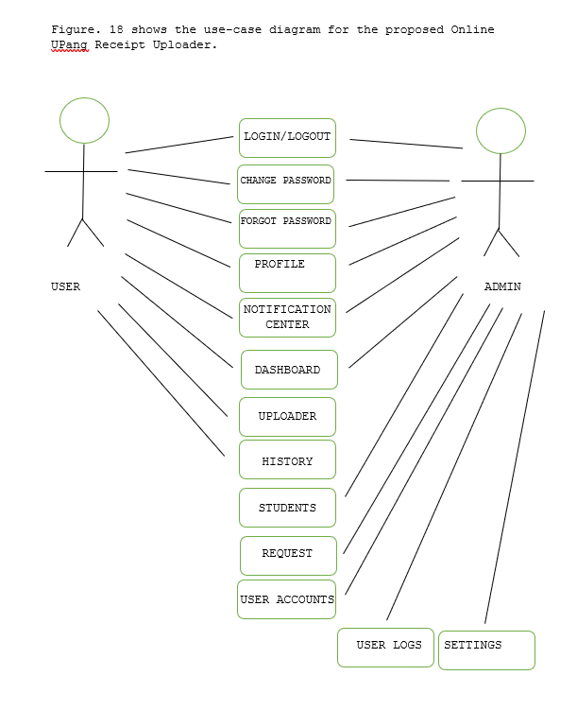

System Architecture. A system architecture is a conceptual model that defines the structure, behavior, and more views of a system. The three-tier architecture has been used in this study. This Three-tier architecture is a client-server architecture in which the functional process logic, data access, computer data storage, and user interface are developed and maintained as independent modules on separate platforms. Three-tier architecture is a software design pattern and a well-established software architecture.

Figure 19 presents the diagram of the systems architecture used in the proposed system.

Figure 19.

Systems Architecture

Presentation tier Application tier Data-tier

HTTP SQL



HTML TABLE

USER

Presentation tier. Occupies the top level and displays information related to services available on a website. This tier communicates with other tiers by sending results to the browser and other tiers in the network.

Application tier. It controls application functionality by performing detailed processing.

Data-tier. Houses database servers where information is stored and retrieved. Data in this tier are kept independent of application servers or business logic.

Software Requirements. The software requirements are a set of configurations and installations that have to be designed and installed in the server in order for the proposed Online Receipt Uploader for PHINMA University of Pangasinan to work.

Table 7.

Software Requirements

**Software Specification**

Authoring Language Hypertext Markup

Language (HTML)

Database MySQL

Editor Sublime Text

Local Server Xampp version 3.3.0

Operating System At least Windows XP

Scripting Language Hypertext Preprocessor (PHP)

Web Browser Google Chrome, Microsoft Edge Mozilla Firefox, Internet Explorer.

Web Design Cascading Style Sheets (CSS)

The proposed Online Receipt Uploader for Phinma-University of Pangasinan was designed using

hypertext preprocessor(PHP), hypertext markup language

(HTML) with the advanced components of cascading stylesheets (CSS) as a front-end that will enable the system to associate with the different functions and control, and access the database using SQL statements. MySQL is used as a back-end to store, maintain and manage the databases integrated into the system. Furthermore, Xampp will be used as a local server and will serve as an interpreter for scripts written in PHP.

Hardware Requirements. Hardware requirements are a set of physical components essentially required to run the applications and system processes.

Table 8

Hardware Requirements

**Hardware Minimum Specifications**

Processor Intel Pentium 4

Memory 256 MB RAM

VGA Memory 256 MB

Database Server 1 GB free space Table 8 presents the hardware requirements of the proposed Online Receipt Uploader for PHINMA University of Pangasinan.

Chapter 4

**CONCLUSIONS AND RECOMMENDATIONS**

This chapter presents the conclusions and recommendations for the proposed Online Receipt Uploader for PHINMA University of Pangasinan.

**Conclusions**

Based on the findings of the study, the researcher concludes that:

1. The issues identified in the existing Online Receipt Uploader to achieve information quality are: Prolonged processing of receipts, and time-consuming for Receipt Uploader Section; Time-consuming data entry and Inaccuracy of data for Request Record; Data modification anomaly for data validity of Student Record; and Time-consuming for Payment History.

2. The features of the proposed Online Receipt Uploader are Uploader, Request Record, Student Record, and Payment History.

3. The level of acceptability of the proposed Online Receipt Uploader is Acceptable for all the factors measured namely usefulness, ease of use, ease of learning, and satisfaction.

**Recommendations**

Based on the above findings and conclusions of the study, it is highly recommended that the Online Receipt Uploader be implemented

1. The proposed Online Receipt Uploader system has to be implemented to improve the existing system.

2. Training and system orientation for Admin Officer and all concerned employees.

3. Maintenance of the proposed Online Receipt Uploader system should be coordinated with the Information Technology System Department and/or the College of Information Technology  Education.

4. Assessment of the proposed system has to be conducted regularly.

**REFERENCES**

A. Published Materials

Hendy Mustiko Aji, Izra Berakon & Maizaitulaidawati Md Husin | Albert W. K. Tan (Reviewing editor) (2020), COVID-19 and e-wallet usage intention: A multigroup analysis between Indonesia and Malaysia, Cogent Business & Management

Seale, H.; Dyer, C.; Abdi, I.; Rahman, K.M.; Sun, Y.; Qureshi, M.O.; Dowell-Day, A.; Sward, J.; Islam, M.S. Improving the impact of non-pharmaceutical interventions during COVID- 19: Examining the factors that influence engagement and the impact on individuals.

About Hungary—Coronavirus Update: Contactless Payment Limit .Ruiz-Real, J.L.; Nievas-Soriano, B.J.; Uribe-Toril, J. Has Covid-19 Gone Viral? An Overview of Research by Subject Area. Health Educ. Behav. (2020), 47, 861–869. Raised to HUF 15,000 to Help Reduce Virus. Available online: http://abouthungary.hu/news-in-brief/coronavirus- update-contactless-payment-limit-raised-to-fifteen-thousand-forintsthis-too-serves-to-slow-down-spread-of-the-virus/ (accessed on 9 February 2021)

**APPENDICES**

Appendix A

Republic of the Philippines

**PHINMA - University of Pangasinan**

**College of Information Technology Education**

Arellano St., Dagupan City 2400

**Informed Consent:**

Thank you for taking the time to complete this survey; your input is valuable. Please be as truthful as possible when answering the following question. These are questions concerning the Online Receipt Uploader for PHINMA University of Pangasinan.

This survey's goal is to assist the developer in determining how well this Online Receipt Uploader functions and we don't think taking this survey will put you at risk or cause you any inconvenience. Furthermore, your participation is entirely voluntary, and you may quit at any moment without incurring any penalties. All information gathered will be used solely for the purposes of this project's development. There will be no reference to you in the result or in any subsequent publication of the result. If you choose, we would be pleased to share the results with you once the study is concluded. In the interim, you can contact the following people if you have any questions or concerns regarding participating in the study: Janine De [Guzman -](mailto:Guzman-jaec.deguzman.up@phinmaed.com) [jaec.deguzman.up@phinmaed.com](mailto:jaec.deguzman.up@phinmaed.com). In answering our survey, you have already read and understood the explanation and agreement of the study.

Part I. For the following questions below, please provide a [√] check inside the boxes for your response.

1. Name(Optional: __________

2. Year Level:

[  ] High school

[  ] First Year

[  ] Second Year

[  ] Third Year

[  ] Fourth Year

[  ] Fifth Year

3. Course: __________

PART II. DETAILS OF EXPERIENCED: Knowing your experiences on Online Receipt Uploader, provide a [ √ ] check inside the box of your chosen answer.

4. How do you upload your proof of payment?

[  ] Google Form

[  ] Google Classroom

5. How much time do you spend uploading proof of payment using the above-mentioned sites?

[  ] 3-5 minutes

[  ] 6-10 minutes

[  ] 11 minutes and above

6. How frequently do you run into issues while utilizing the sites indicated above?

[  ] Never

[  ] Sometimes

[  ] Often

[  ] Always

7. How likely are you to use our online receipt uploader?

[  ] Very Likely

[  ] Likely

[  ] Neutral

[  ] Unlikely

[  ] Very Unlikely

8. Do you want to change your proof of payment uploading method?

[  ] Yes

[  ] No

If your answer is Yes in number 8, please answer the following statements below. Select one for each statement.

9. I'd like to save time and effort when it comes to uploading my proof of payment.

[  ] Agree

[  ] Neutral

[  ] Disagree

10. I’d like to be notified when my proof of payment is approved.

[  ] Agree

[  ] Neutral

[  ] Disagree

11. I’d like a system that would notify the finance when I uploaded my payment.

[  ] Agree

[  ] Neutral

[  ] Disagree

12. I’d like a more secure way when uploading my proof of payment.

[  ] Agree

[  ] Neutral

[  ] Disagree

13. I’d like a fast and user-friendly system when uploading my proof of payment.

[  ] Agree

[  ] Neutral

[  ] Disagree

Appendix B

**Post-test Questionnaire**

The researchers gathered information for their study using the questionnaire presented.

**Online Receipt Uploader for Phinma University of Pangasinan Survey Questionnaire**

**Instructions:** Please put a check mark beside your chosen answer(s).

| **USEFULNESS** | **1** | **2** | **3** | **4** | **5** |
| --- | --- | --- | --- | --- | --- |
| 1. It enables me to be more productive. |  |  |  |  |  |
| 1. It enables me to work more efficiently. |  |  |  |  |  |
| 3.It is useful. |  |  |  |  |  |
| 4. It makes it easier for me to do the tasks I wish to complete. |  |  |  |  |  |
| 5. It doesn't take much time when I use it |  |  |  |  |  |
| **EASE OF USE** | **1** | **2** | **3** | **4** | **5** |
| 6. It is user-friendly. |  |  |  |  |  |
| 7. It is adaptable. |  |  |  |  |  |
| 8. It is flexible |  |  |  |  |  |
| 9. I can use it successfully every time . |  |  |  |  |  |
| 10. The interface of the system is pleasant. |  |  |  |  |  |
| **EASE OF LEARNING** | **1** | **2** | **3** | **4** | **5** |
| 11. It is simple for me to learn how to operate the system. |  |  |  |  |  |
| 12. I learned to use it quickly |  |  |  |  |  |
| 13. It is simple for me to recall how to use the system to complete tasks |  |  |  |  |  |
| 14. I can use it without written instructions. |  |  |  |  |  |
| 15. I can easily recover from the errors. |  |  |  |  |  |
| **SATISFACTION** | **1** | **2** | **3** | **4** | **5** |
| 16. I am satisfied with it |  |  |  |  |  |
| 17. I would recommend it to a friend |  |  |  |  |  |
| 18. It is fun to use |  |  |  |  |  |
| 19.It works the way I want it to work |  |  |  |  |  |
| 20. I feel I need to use it |  |  |  |  |  |

**CURRICULUM VITAE**



**JULIAN GABRIEL MARK S.CRUZ**

#08 Arzadon Compound Mayombo District,

Dagupan City

09503719613

ianguittap17@gmail.com

**___________________________________________________________**

**PERSONAL INFORMATION**

Birthdate: October 17, 2000

Civil Status: Single

Gender: Male

Religious Affiliation: Roman Catholic

**___________________________________________________________**

**EDUCATIONAL ATTAINMENT**

Tertiary: Bachelor of Science in Information Technology, Phinma-University of Pangasinan, 2019 - Present

Secondary: Escuela De Nuestra Señora De La Salette 2019

Elementary: Escuela De Nuestra Señora De La Salette,

2013

**___________________________________________________________**

**WORK HISTORY**

Service Crew

Chowking Fast food Restaurant

(May 2019-August 2019)

McArthur Highway corner , Judge Jose de Venecia Ave, Nansian, Calasiao

**___________________________________________________________**

**IT SKILLS AND CERTIFICATIONS**

1. Computer Skills,
2. Problem Solving Skills,
3. Collaboration



**JOSHUA Z. QUISAO**

#261 Lumnbang Calasiao, Pangasinan

09278600798

joza.quisao.up@phinmaed.com

**___________________________________________________________**

**PERSONAL INFORMATION**

Birthdate: February 27, 2000

Civil Status: Single

Gender: Male

Religious Affiliation: Roman Catholic

**___________________________________________________________**

**EDUCATIONAL ATTAINMENT**

Tertiary: Bachelor of Science in Information Technology, Phinma-University of Pangasinan, 2018 - Present

Secondary: Calasiao Comprehensive National High School,

2018

Elementary: Lumbang Elementary School,

2012

**___________________________________________________________**

**IT SKILLS AND CERTIFICATIONS**

1. Web Design with HTML & CSS

2. Photoshop

3. Video Edting



**ERICK JOHN A. AQUINO**

#255 Linoc Binmaley, Pangasinan

09952534857

eraq.aquino.up@phinmaed.com

**___________________________________________________________**

**PERSONAL INFORMATION**

Birthdate: September 13,2001

Civil Status: Single

Gender: Male

Religious Affiliation: Christian

**___________________________________________________________**

**EDUCATIONAL ATTAINMENT**

Tertiary: Bachelor of Science in Information Technology, Phinma-University of Pangasinan, 2019 - Present

Secondary: Manila Montessori College International,

2019

Elementary: Linoc Elementary School,

2013

**___________________________________________________________**

**IT SKILLS AND CERTIFICATIONS**

1. Have a knowledge in HTML, CSS
2. Communication Skills
3. Proficient in Microsoft Office, Excel and Powerpoint

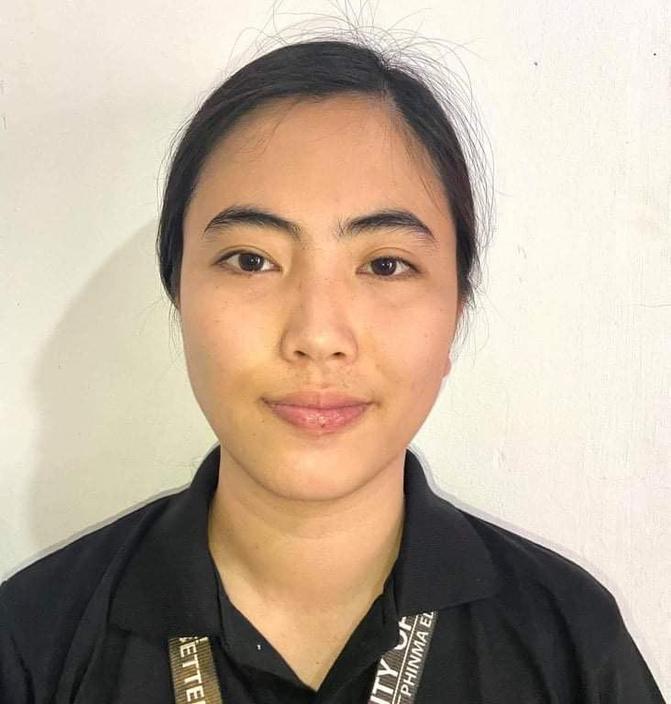

**VICKY A. BARROZO**

#306 Caloocan Sur, Binmaley, Pangasinan

09190957613

viaq.barrozo.up@phinmaed.com

**_________________________________________________________________**

**PERSONAL INFORMATION**

Birthdate: November 5, 2000

Civil Status: Single

Gender: Female

Religious Affiliation: Roman Catholic

**___________________________________________________________**

**EDUCATIONAL ATTAINMENT**

Tertiary: Bachelor of Science in Information Technology, Phinma-University of Pangasinan, 2019 - Present

Secondary: Manila Montessori College International,

2017

Elementary: Caloocan Sur Elementary School,

2011

**___________________________________________________________**

**IT SKILLS AND CERTIFICATIONS**

1. Proficient in Microsoft Office, Excel and Powerpoint
2. Have a knowledge in HTML
3. Managing Computer Files



**KIM CHARLIE L. DELOS SANTOS**

Sobol San Fabian, Pangasinan

09159792488

kilo.delossantos.up@phinmaed.com

**_________________________________________________________________**

**PERSONAL INFORMATION**

Birthdate: May 25, 2000

Civil Status: Single

Gender: Male

Religious Affiliation: Roman Catholic

**___________________________________________________________**

**EDUCATIONAL ATTAINMENT**

Tertiary: Bachelor of Science in Information Technology, Phinma-University of Pangasinan, 2018 - Present

Secondary: Phinma-University of Pangasinan,

2018

Elementary: Teodoro T. Cacapit, Elementary School

2012

**___________________________________________________________**

**IT SKILLS AND CERTIFICATIONS**

1. Have knowledge in Web Development using HTML, CSS, JavaScript, PHP.
2. Capable in using MS Office (Word, Powerpoint, Excel)
3. Can and willingness to learn under minimal supervision.



**JANINE C. DE GUZMAN**

#420 Rosari West, Lingayen, Pangasinan

09303754745

jaec.deguzman.up@phinmaed.com

**_________________________________________________________________**

**PERSONAL INFORMATION**

Birthdate: January 12, 2001

Civil Status: Single

Gender: Female

Religious Affiliation: Roman Catholic

**___________________________________________________________**

**EDUCATIONAL ATTAINMENT**

Tertiary: Bachelor of Science in Information Technology, Phinma-University of Pangasinan, 2019 - Present

Secondary: Pangasinan School of Arts and Trades,

2019

Elementary: Rosario Elementary School,

2013

**___________________________________________________________**

**IT SKILLS AND CERTIFICATIONS**

1. Have a knowledge on HTML, CSS and Python
2. Have a knowledge in Microsoft Office, Excel and Powerpoint.